Department of Accounts
Payroll Bulletin

Calendar Year 2024 | January 29, 2024 | Volume #2024-03

In This Issue of the Payroll Bulletin….... | - W-4 Exemption Reset | The Payroll Bulletin is published periodically to provide CIPPS agencies guidance regarding Commonwealth payroll operations. If you have any questions about this bulletin, please send an email to payroll@doa.virginia.gov  State Payroll Operations  Director Cathy McGill  Assistant Director Carmelita Holmes

W-4 Exemption Reset

2023 W-4 Exemptions  Expire Feb 15 | As mentioned in the #2024-01 Payroll Bulletin, employees who claim exempt from withholding on their W-4 during the prior year must complete a new W-4 form by February 15th to maintain their exempt status. If a newly completed W-4 form is not received by February 15th, agencies must immediately begin to withhold Federal income tax as if they had checked the box for Single or Married filing separately in Step 1(c) and made no entries in Step 2, Step 3, or Step 4 of the 2020 Form W-4. If the employee gives you a new Form W-4 claiming exemption from withholding after February 15, you may apply the exemption to future wages, but don't refund taxes withheld while the exempt status wasn't in place.  IRS regulations stipulate which employees are eligible to file a W-4 Form with exempt status. Refer to Section 9 of Publication 15 (Circular E) for more information.  https://www.irs.gov/pub/irs-pdf/p15.pdf page 24-25

HCM Process | Agency - Identify Employees Claiming Exemption from FIT  a. W-4 Exemptions Report (TAX100) - lists all employees whose U.S. Tax Data records indicate that they are exempt from federal income tax withholding (W-4).  Navigation: Payroll for North America > U.S. Annual Processing > Year-End/New Year Preparation > W-4 Exemptions Report > W-4 Exemptions Report  b. Agency - Employee Tax Set Up Query – A list of all employees set up, filter on the Federal Status  Agency – Ensure Employees Have Valid Emails  Employees must have a valid email address in HCM. The following data query can be run to identify employees with no email addresses: V_HR_MISSING_EMAIL. Work with HR to ensure employee emails are set up as soon as possible.

W-4 Exemption Reset, continued

HCM Process, cont. | Cardinal - Notify Employees  On February 1, 2024, Cardinal will run a job that will automatically generate emails to all active employees who are exempt, have a valid email address in HCM and have not submitted a new W-4 and will set the “Notification Sent” flag on the federal tax data page.  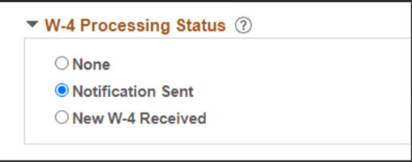  Payroll Admins - Update Federal Tax Data Page  As received, Payroll Admins insert a new effective date and update the federal tax data page with the new W-4 information. Payroll Admins must also remember to check the “New W-4 Received” radio button before saving the record.  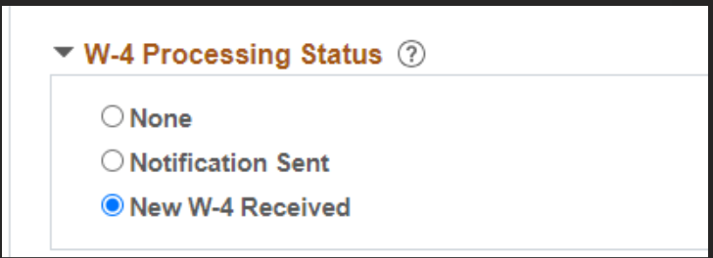  State Payroll Operations – Reset Status  SPO will run a job the morning of February 16, 2024, that will add a new effective-dated row and change all previously exempt employees (still show “Notification Sent” radio button) who did not submit new forms to the default status as required by the IRS. This program is only for the federal forms; Virginia forms must be maintained manually.

