Department of Accounts
Payroll Bulletin

Calendar Year 2024 | January 22, 2024 | Volume #2024-02

In This Issue of the Payroll Bulletin….... | - W-2s for Other States  - Create State W-2 Files  - Create State W-2 PDF Forms | The Payroll Bulletin is published periodically to provide CIPPS agencies guidance regarding Commonwealth payroll operations. If you have any questions about this bulletin, please send an email to payroll@doa.virginia.gov  State Payroll Operations  Director Cathy McGill  Assistant Director Carmelita Holmes

W-2s for Other States

State Tax Reporting | DOA automatically creates and submits the annual W2 file for Virginia withholding to the Virginia Department of Taxation, but agencies are responsible for reporting and submitting all required files/reports to all other states.

To facilitate reporting, instructions on how to create a pdf and an electronic file can be found at the end of this bulletin. Agencies are encouraged to ensure that federal W2s have been finalized before creating state reports.

Reminder to PSB agencies – please co-ordinate with PSB.

State Requirements | Take time to review the individual state requirements before you begin to create the files/reports. Here are links to our neighboring states:  MARYLAND  www.marylandtaxes.gov/forms/23_forms/2023_Maryland_Employer_Reporting_of_W2s_Instructions_and_Specifications.pdf  WEST VIRGINIA  https://tax.wv.gov/Documents/Withholding/2023/it105.2023.pdf  NORTH CAROLINA  https://www.ncdor.gov/ty2023enc3w2pdf/open  DISTRICT OF COLUMBIA  https://otr.cfo.dc.gov/sites/default/files/dc/sites/otr/publication/attachments/2023%20W2_W2C%20instructions%20v1.0%20Final.pdf  KENTUCKY  https://revenue.ky.gov/Business/PublishingImages/Pages/Employer-Payroll-Withholding/2023-Specification%20for%20Electronic%20Submission%20of%20Annual%20Wage%20and%20Tax.pdf  PENNSYLVANIA  https://www.revenue.pa.gov/TaxTypes/EmployerWithholding/Pages/Electronic-Filing-Requirement-W2-Forms.aspx
Continued on next page

Create State W-2 Files

This will produce a file for COVA agencies to use for non-VA state W-2 reporting requirements. It can then be uploaded to the respective state’s website or submitted as a file if required by the state
Navigation: Menu > Payroll for North America > U.S. Annual Processing > W-2 Reporting > COVA Create State W-2 File
Add Run Control
Enter Parameters – See screenshots example and instructions below.
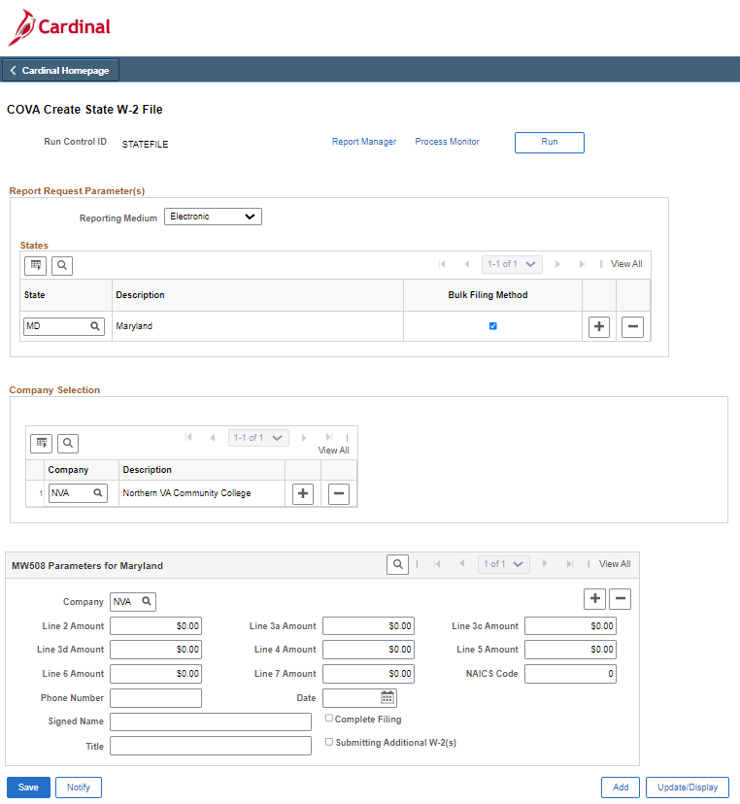

Create State W-2 Files, continued

- Reporting Medium – Leave as ‘Electronic’
- State - Enter the state code desired for the file.
- Company Selection - Enter the desired company code for the respective file.
- Some states have extra parameters at the bottom of the page. Fill in fields according to requirements by each state.
- Save
- Click Run
- Click OK on Process Scheduler Request

Click on the Process Monitor link
Once the process has status of Success, click on Details. Two files are created: 1) PDF containing a summary report. 2) txt file containing employee W-2 file for electronic submission to the state.
Save the files in your desired folder.

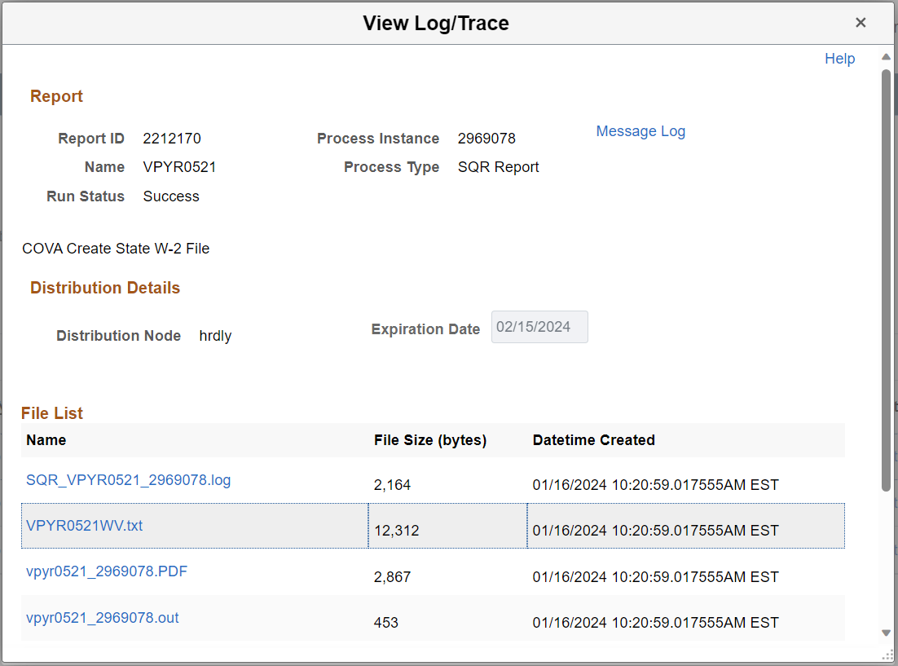

Create State W-2 Files, continued

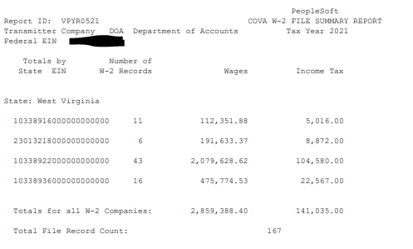

The file may also be created as a csv file. On the Process Scheduler select CSV in the Format field.
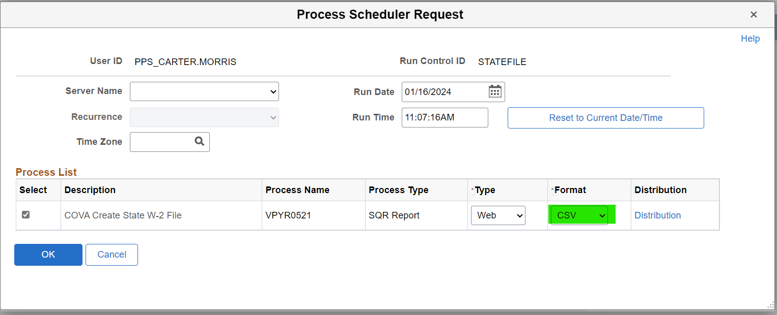

Click the csv link to open the file. Save as needed.

Create State W-2 Files, continued

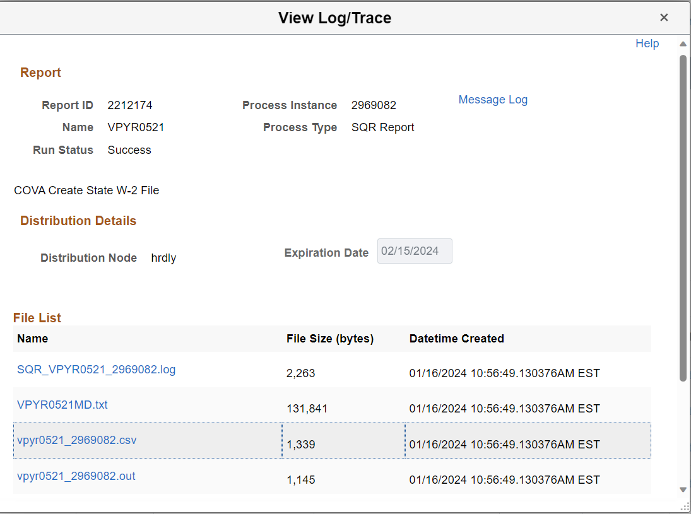

Create W-2 PDF Forms

Navigation: Menu > Payroll for North America > U.S. Annual Processing > W-2 Reporting > Create W-2 PDF Forms
Add Run Control
Enter Parameters – See screenshots and instructions below.
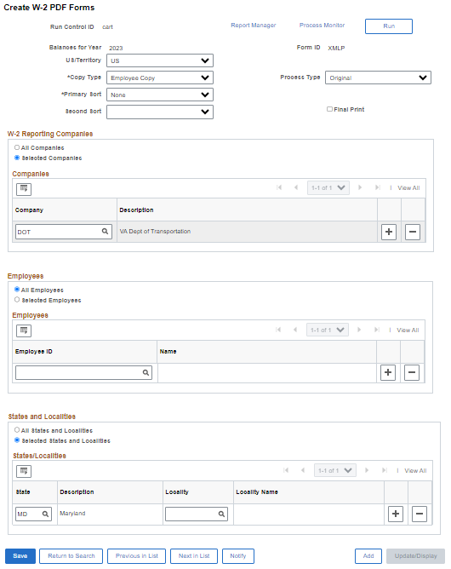

Create W-2 PDF Forms, continued

Run Control Parameters
  - US/Territory – Leave defaulted value ‘US’
  - Copy Type – Select desired value
  - Primary Sort – Select desired value. None = By Company then Employee Name
  - Second Sort – Select desired value.
  - Process Type – Leave as ‘Original’

- W-2 Reporting Companies
- Choose radio button = Selected Companies
- Enter desired company code(s). Use the (+) sign to add a row for multiple companies.

- Employees
  - Select desired option. All Employees will generate PDF W-2s for all employees in the selected company(s). If selected by Employees, enter each Employee ID desired.

- States and Localities
  - DO NOT Select ‘All States and Localities’. This will generate Virginia forms and a very large file.
  - Select the radio button for ‘Selected States and Localities’. You can add rows for multiple states or choose one state at a time. A State code must be entered.

After all parameters are entered, click Save, then Run. On the Process Scheduler Request page select ‘W-2 for US’ only.
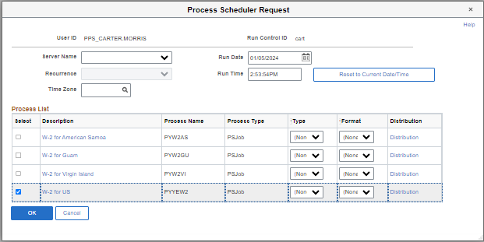
Click OK. The process will begin.
Once the process Run Status runs to Success the job is complete.

Create W-2 PDF Forms, continued

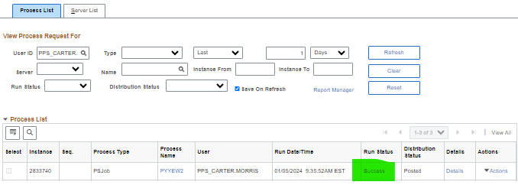

The PDF W-2 forms will be available in Report Manager.
Navigation: Menu > Reporting Tools > Report Manager
Two report files are generated:
- TAX960US – This provides totals of the W-2 boxes. Click the file link for result.
- PYW222N_EE.PDF – This is the file containing the PDF W2s. Click the file link for results, then click again on the following Report Index page. The PDF file will open.
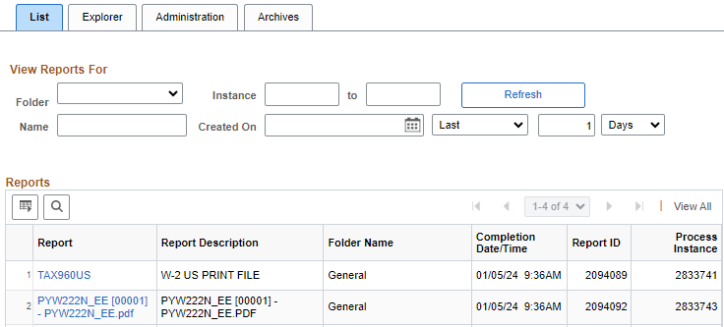

Create W-2 PDF Forms, continued

