Tip of the Month – Political Subdivisions - PA Updates – COV Contract

- For Political Subdivisions (PSUBS), we would like to request PA updates be submitted to the Charge Card Administration (CCA) team at DOA. The CCA team maintains a database of PSUB Program Administrators (PA) in order to notify PSUBS for industry updates, information on the Annual Card Summit, bi-monthly PA meetings, etc. The CCA team will then send the update to the Bank of America Dedicated Rep, Sarhonda.
- You can download the PA update form using the link below: https://www.doa.virginia.gov/forms.shtml#ChargeCard

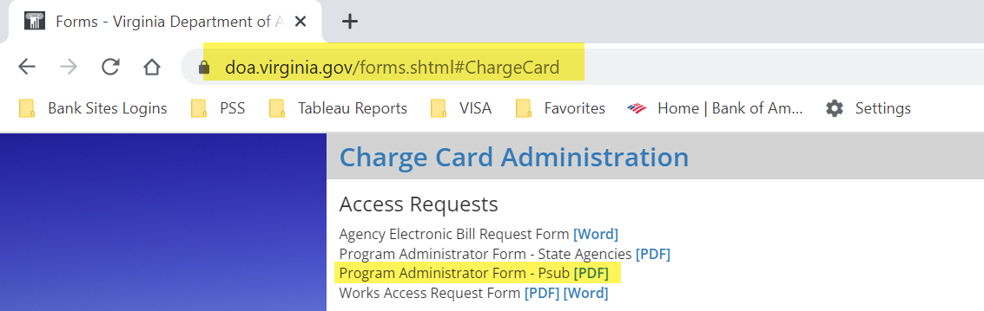

Annual Training – For State Agencies Only

- The 2023 trainings have been uploaded in COVLC. Annual training for all cardholders, PAs, and supervisors must be completed by June 30, 2023.

Annual Certifications – For State Agencies Only

- Annual Training Certifications are due June 30, 2023.
- Annual Cardholder Review Certifications are due May 31, 2023.
- Annual Security Review is due May 31, 2023.

Annual Exceptions – For State Agencies Only

- Annual Exception Requests are due May 31, 2023.
- Any permanent restriction removal must be included on the Exception Request Form and submitted for approval. This includes all restrictions lifted on Gold Cards, if applicable.
- Acceptable reasons for exceptions.
  - Auto Pay
  - Increased SPCC Limits
  - Unusual Requests
- Exceptions MUST be submitted via email to cca@doa.virginia.gov. Do not submit via Secure Email in the CCA Database.
- Exceptions must be in Word format.

CAPP Updates – For State Agencies Only

- Effective May 1, 2023, updates to CAPP 20355 and CAPP 20360 were published to DOA's website.
- Please see the linked Memo for the latest CAPP updates: https://www.doa.virginia.gov/reference/CAPP/Update_Memos/CAPP_Memo_181.pdf
- CAPP 20355 – Purchasing Charge Card
https://www.doa.virginia.gov/reference/CAPP/CAPP_Topics_Cardinal/20355.pdf
- CAPP 20360 – Travel Charge Card
https://www.doa.virginia.gov/reference/CAPP/CAPP_Topics_Cardinal/20360.pdf

Gold Card Analysis | Gold Card Employee Agreements
- Annual Gold Card Analysis are complete, and all suggested changes have been made.
- The deadline to submit Gold Cardholder Employee Agreements for all Gold Cardholders in your agency is Thursday, May 18, 2023.
- The Gold Cardholder Employee Agreement has been updated to include the following verbiage:
  - I understand that any personal charges made on the Gold Card may result in payroll deduction.

Cardholder Employee Agreements – SPCC, ATC, IL Travel
- All Cardholder Employee Agreements have been updated to include the following verbiage:
  - SPCC: I understand that any personal charges made on the SPCC may result in payroll deduction.
  - ATC: I understand any personal charges made on the ATC Card may result in payroll deduction.
  - IL Travel: I understand that any personal charges or unpaid balances made on the IL Travel Card may result in payroll deduction.
- Please ensure that all cardholders complete a new agreement for your internal records.

Reminders:
- Please use the CCA Automated Online Forms Request System. Email requests for paying late invoices, credit limit increases, temporary restriction removal, and submission of annual certifications will not be accepted.
- Troubleshooting- if you are having issues logging on to https://cca.doa.virginia.gov/Login.cfm, please contact cca@doa.virginia.gov.
- DOA offers Monthly Program Administrator Training for all new PA’s as well as those who need a refresher. Training will be offered via Microsoft Teams on the first Tuesday of each month. Each monthly training session will be from 8:30 am to 12:00 pm. To register, please email cca@doa.virginia.gov. This monthly training will allow PA’s to receive detailed instructions about their responsibilities and day-to-day functions as a Program Administrator.
- The Commonwealth has a package relationship with NAPCP in order to get a (discounted) $99 membership rate. When you sign-up initially or renew your membership to this organization, please contact DOA for coupon code to receive your discounted membership rate.
- When contacting CCA, please call 804-786-0874 to leave a voicemail or email cca@doa.virginia.gov. Email is the best way to contact us. If your request is urgent, please mark it accordingly when sending an email. Do not send maintenance requests to individuals within the unit.
- When contacting Sarhonda Finklea-Frett or Company Level Support at BOA, please email Dedicated_Card_East@bankofamerica.com. Please include your company number in all correspondence.
- DOA will be reviewing IL Travel cards monthly and PAs will be informed if the cardholder is past due more than 1 day. At 31 days past due, the PA must suspend the IL Travel Card. At 61 days past due, the agency TPA will need to cancel the card and submit the past due travel card balance to be deducted from the cardholder’s payroll.
  - Program Administrators must review the delinquency reports in Works at least every two weeks to ensure cardholders are making timely payment for their IL cards.
- Agencies should evaluate the number of CL and STL increase requests and ensure the limits are in line with the cardholder’s needs. If you find that the cardholder regularly goes over the cycle limit, card limit, or single transaction limit, please review the need for a Gold Card at your agency.

Contact Information for CCA:
- CCA: cca@doa.virginia.gov
- vPay: ecommerce@doa.virginia.gov
- 804.786.0874

