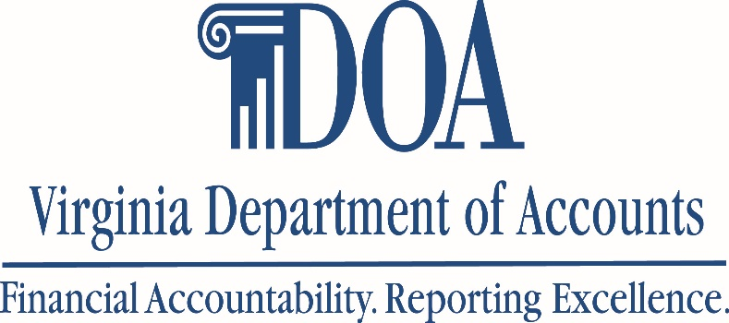

PA Monthly Newsletter
1/10/24

Global Card Access | Reminder:  Governor’s Memo | Certifications

Global Card Access

Phasing out Payment Center

As you may have heard, Payment Center’s application is being discontinued by Bank of America.
Cardholders (and Program Administrators) are being advised to register in Global Card Access (GCA) to obtain individual cardholder statements and corporate statements. While we do not have a definitive date for discontinuance, many users are already reporting the inability to access Payment Center.

Please view the attachments below for information and instructions on registering:

http://www.bofa.com/globalcardaccess
https://www.bofaml.com/content/dam/boamlimages/documents/PDFs/gca-registration.pdf

Program Administrators who need assistance with registering corporate accounts can reach out to CCA for assistance.

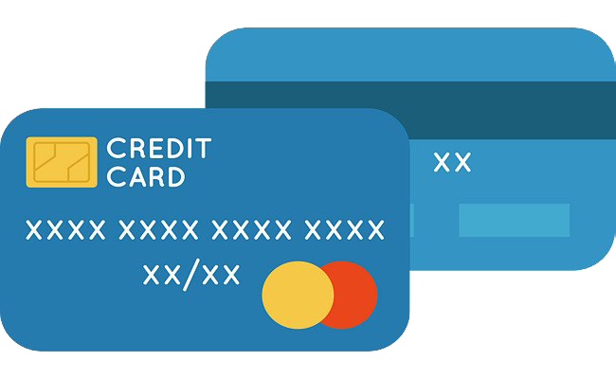

Governor’s Memo

Reminders
Governor’s Memo emailed September 8, 2023, outlining changes to the SPCC Program.
As a reminder, the following changes have been implemented regarding the SPCC Program. Please ensure complete compliance with the following:
- Cards that have been inactive for a period of 120 days must be closed immediately. Program Administrators must run a quarterly Inactivity Report to identify cards subject to closure.
- Program Administrators are prohibited from having their own cards.
- Pause on issuance of new cards (SPCC and Gold).
*If an agency has less than 25 employees, CCA may grant an exception for the PA to maintain a card.
*Agencies requesting exception to the memo must submit the exception to their Cabinet Secretary.

Certifications

Reminders
Multiple Cardholder Certifications
With Annual Certifications fast approaching, Program Administrators must be mindful to submit complete and correct certifications.
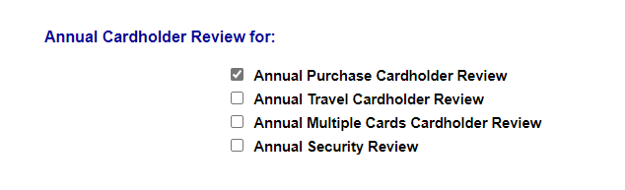
- Select the boxes for the appropriate program you administer.
- Annual Multiple Cardholder Review
  - PA’s must select this box for cardholders who are issued multiple cards either from the same corporate account (SPCC) or different corporate accounts (SPCC and Emergency). (This box is not applicable to employees who are issued an SPCC and Travel).
- Annual Security Review box must be selected
  - You must certify that all WORKS users and roles are valid and necessary. All access has been removed for users who have separated from the agency or whose job functions no longer support access to the WORKS system. Employees no longer requiring the accountant or auditor roles for report functions shall have their access removed immediately.
- Program Administrators must review each card account in their program to verify that spend limits (Single Transaction Limit and Credit Limit) and restriction removals are appropriate for each individual cardholder. Please make necessary adjustments as needed.
- As a reminder, if your cardholder has been issued multiple cards, they must be listed, with justification, on your Agency Exception and submitted to CCA for review and approval.

Reminders:
- Please use the CCA Automated Online Forms Request System. Email requests for paying late invoices, credit limit increases, temporary restriction removal, and submission of annual certifications will not be accepted effective July 1, 2016.
- Emails containing sensitive information such as last 4 digits, transactional information, etc. must be encrypted before sending to CCA. If your agency does not utilize encryption, please send an email to CCA, and request an encrypted email be sent. DO NOT USE THE SECURE EMAIL FUNCTION IN THE CCA DATABASE.
- Troubleshooting- if you are having issues logging on to https://cca.doa.virginia.gov/Login.cfm, please email cca@doa.virginia.gov.
- DOA offers Monthly Program Administrator Training for all new PA’s. Training will be offered via WebEx on the first Tuesday of each month. Each monthly training session will be from 8:00 am to 12:00 pm. To register, please email cca@doa.virginia.gov. The monthly training will provide detailed instructions about the responsibilities and day-to-day functions as a Program Administrator.
- The Commonwealth has a package relationship with NAPCP to get a (discounted) $99 membership rate. When you sign-up initially or renew your membership to this organization, please contact DOA for coupon code to receive your discounted membership rate.
- When contacting CCA, please call 804-786-0874 to leave a voicemail or email cca@doa.virginia.gov. Email is the best way to contact us. If your request is urgent, please mark it accordingly when sending an email. Do not send maintenance requests to individuals within the unit.
- When contacting Sarhonda Finklea-Frett or Company Level Support at BOA, please email Dedicated_Card_East@bankofamerica.com . Please include your company number in all correspondence.
- DOA will be reviewing IL Travel cards monthly and PAs will be informed if the cardholder is past due more than 30 days. At 61 days past due, BOA will automatically suspend any past due card accounts. At this time, the agency TPA will need to submit the past due travel card balance to be deducted from the cardholder’s payroll.
  - Program Administrators must review the delinquency reports in Works at least every two weeks to ensure cardholders are making timely payment for their IL cards.
- Agencies should evaluate the number of CL and STL increase requests and ensure the limits are in line with the cardholder’s needs. If you find that the cardholder regularly goes over the cycle limit, card limit, or single transaction limit, please review the need for a Gold Card at your agency.
Contact Information for CCA:
- cca@doa.virginia.gov 804.786.0874

