

Administrative
Manual
For
Employers

May 2012

Table of Contents

Payline Overview 1
Navigation 4
Accessing Payline 5
Special Announcements Page 30
Personal Messages Page 31
Main Menu Page 32
Personal Options Page 34
Pay History Screen 50
Pay History Detail Inquiry 53
Payment Information 56
Agency Paid Contributions Detail 58
Presentation of Taxable Wages 59
Direct Deposit Detail and Additional Profile Data 60
Reported Leave Balances 61
Leave History 62
Leave Balances 63
Bonus, Compensatory, and Recognition Leave Detail 65
Leave Detail 66
Leave History Detail Inquiry 67
Administrative Logons 70
Statistical Reporting 75
Employee Number Lookup 81
Temporary Security Records 84
Attachment A 87

Payline Overview

Introduction | DOA has developed a web-based system that provides participating State employees with online viewing of their earnings, benefits, and leave information. Employees may access Payline using the internet at http://payline.doa.virginia.gov.  Payline has been designed to be as user-friendly as possible and require little intervention from outside resources. However, DOA realizes that there may be some functions that individuals may need assistance with and has developed this administration manual to aid agency personnel in responding to employee inquiries.

PAYLINE Features | Payline provides Commonwealth of Virginia Employees paid through the Commonwealth Integrated Personnel and Payroll System (CIPPS) the means to:  - View current payment information at least 4 working days before the payment date.  - View current and year-to-date earnings including regular pay, overtime, shift pay, and special payments.  - View current and year-to-date deductions withheld (both employee and employer).  - View Federal and State taxable wages as well as individual tax elections and associated withholdings.  - View direct deposit information and associated deposit amounts.  - View leave information on-line as soon as period end processing is completed eliminating the pay period lag for access to leave balances (if the agency participates in CIPPS Leave).  - Provide historical payment and leave information on the system for 24 months.  - Allow the employee to alert the agency of desired changes to the employee’s address or tax elections.  - View current and past years W-2s. Also, the user has the ability to opt-out of displaying W-2s.

Continued on next page
Payline Overview, Continued

Security | State-of-the-art security features are provided to maintain confidentiality of the individual employee's personal payroll information.  - Application Security - requires a user id and password for system access. Individuals will be required to keep this information confidential to provide the utmost security to their individual records.  - Secure Socket Layer - SSL - uses a 128-bit encryption routine to protect the data as it travels back and forth over the Internet.  - Elliptic Curve Cryptograph - ECC - is a server-based program that protects sensitive data and prevents unauthorized access to the server.

Access Requirements | - Browser must be enabled for Java Script.  - Browser must be enabled for Cookies.  - Browser must be enabled for Secure Socket Layer (SSL) Security (128-bit version).  - If connecting to the site from behind a firewall or proxy server it must allow SSL (port 443) communication.  - Internet Explorer or Netscape browsers, version 4.0 or higher.  - Designed to be viewed at a screen resolution of 800 by 600 or greater, with a minimum of 256 colors.  - Connection speed of 56k modem (or higher) is highly recommended.

Web Address | https://payline.doa.virginia.gov

Accessing Payline, Continued

Use of Social Security Number Not Allowed | Users cannot access Payline or request temporary passwords using their Social Security Number (SSN). Agencies should ensure employees are aware of their nine-digit Employee Number. Additionally, the user can click on the ‘What is my employee number?’ prompt beside the box to obtain an explanation of the Employee Number.  All displays of an employee’s SSN have been removed from Payline, except on the Employee’s W-2, to further enhance the security of the employee’s information. The employee will have an option to suppress the viewing of their W-2 information.

Navigation

Introduction | This topic provides guidelines on the use of Payline help and maneuvering from one area to another.  Navigation buttons are located on the left-handed margin of each page. They are used to link the user to other payline pages or perform certain functions. The table below describes the use of most buttons found within the site.

BUTTON | DESCRIPTION
Main Menu | Clicking on this button will link the user to the Main Menu page where the user can begin reviewing his earnings, benefit and leave information.
FAQs | Clicking on this button links the employee to a page of Frequently Asked Questions concerning Payline.
Contact Us | Clicking on this button will allow the user to send an email with suggestions and/or questions to DOA.
Log off | Clicking on this button will return the user to the Log On page and sign the user out of Payline.
Employee Number Look-Up | Clicking on this button will link the user to the Employee Number Look-Up function which allows the user to enter an employee’s name or SSN to find the associated employee number. (Administrative Logon access is required.)
Reporting | Clicking on this button will link the user to the reporting query function page. (Administrative Logon access is required.)
Set Mask | Clicking on this button will link the user to the Masking Page where the employee's User ID is entered and the user can view the employee’s Payline information as if they were the employee. (Administrative Logon access is required.)

Note: More information on the special security access functions can be found later in the manual.

Accessing Payline

First Access for New Users | First time Payline users should access Payline using https://payline.doa.virginia.gov then, click on the Forgot Password/New Account button.

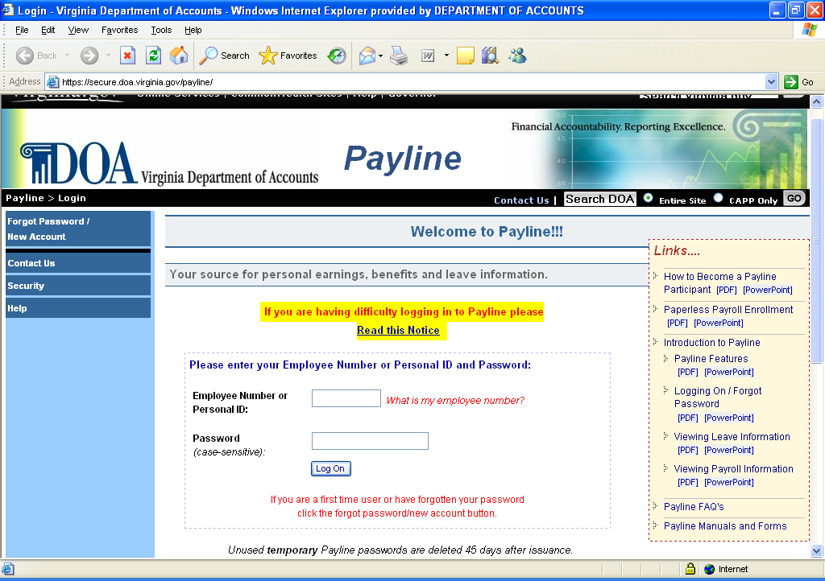

Continued on next page
Accessing Payline, Continued

First Access for New Users, Continued | Users requesting their initial temporary password will have to click on the Forgot Password/New Account button then enter their Employee Number and click on the submit button.  Agencies should ensure employees are aware of their nine-digit Employee Number. Additionally, the user can click on the ‘What is my employee number?’ prompt beside the box to obtain an explanation of the Employee Number on the “WELCOME TO PAYLINE” page.  NOTE: Once the temporary password is received and the user establishes their permanent security record in Payline, the user can create a Personal ID to be used in lieu of the Employee Number using the Personal Options page.
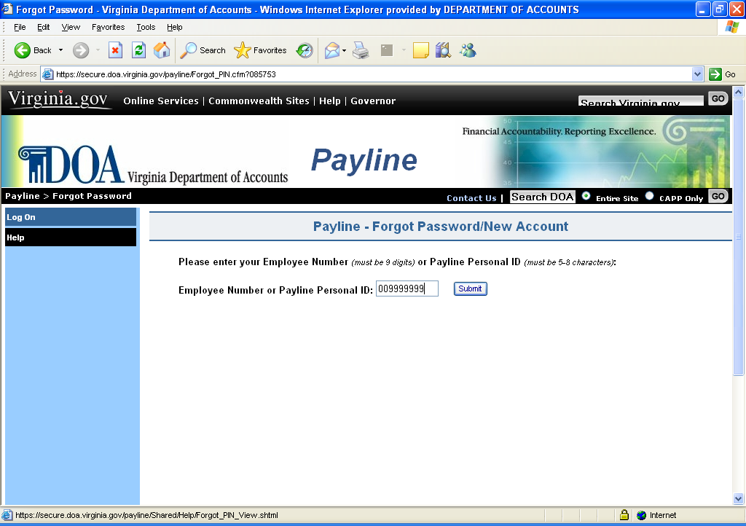

Continued on next page
Accessing Payline, Continued

First Access for New Users, Continued | If an invalid Employee Number is entered, the following message is displayed:  “There are no matching records found for Employee Number = *********. A temporary password cannot be assigned.”  This message indicates that there are no records for the Employee Number in Payline. Payline uses the first 9 characters of the employee’s CIPPS employee ID. Either a data entry error was made in the Employee Number on the Log On screen or the employee has not been paid through CIPPS using the Employee ID entered.  The employee may click on the ‘Log On’ button to return to the Log On screen and re-enter either the Employee ID to try again or wait until the user has been paid.

Continued on next page

Accessing Payline, Continued

First Access for New Users, Continued | If a valid Employee Number is entered, the employee has the option to have the temporary password printed on their next earnings notice (if their agency has not opted out of receiving earnings notices) or sent to their agency’s Human Resource/Payroll office via email. If the employee chooses the email option, the employee must enter the first three letters of his last name, click Send, and then the Human Resource/Payroll office will receive and forward the temporary password onto the employee. The employee must wait for receipt of the temporary password before being able to logon to Payline.

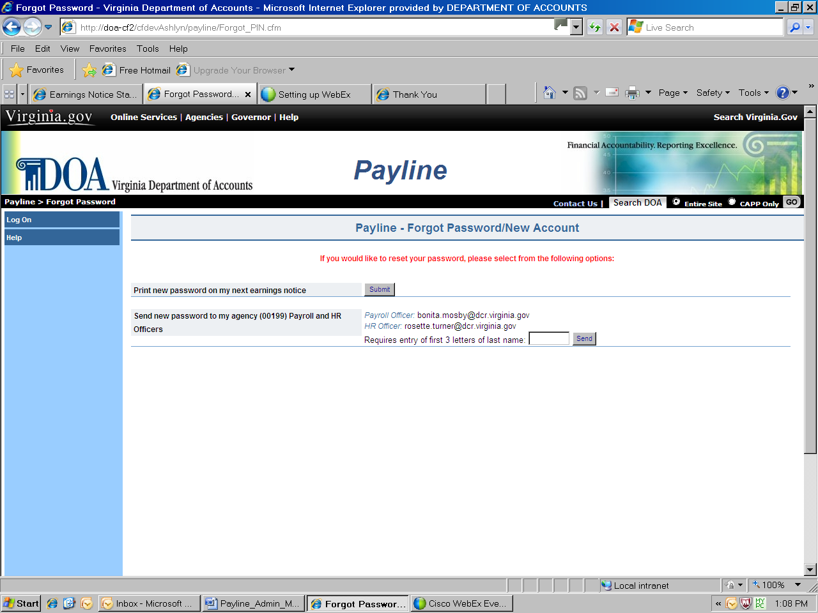

Note: If the agency has opted out of earnings notice print the option to “print new password on my next earnings notice” will not appear.

Continued on next page
Accessing Payline, Continued

First Access for New Users, Continued | The employee will then be prompted to enter a personal Pass Phrase. This Pass Phrase will be used in conjunction with the temporary password to enter Payline. The Pass Phrase can be a word or a phrase up to 24 characters and is not case sensitive. The user will need to remember this pass phrase, if not, they will have to go through the request process again.

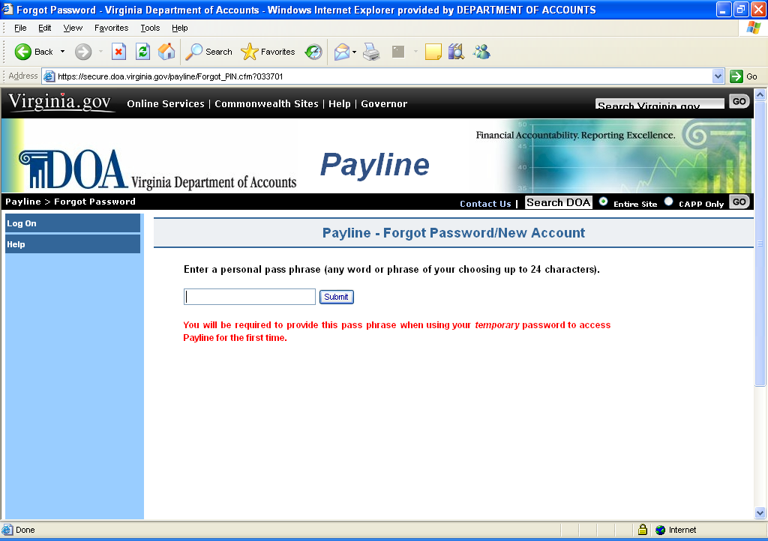

Once the employee presses Submit, they will see one of the following notifications on the screen dependent upon the method chosen to receive their temporary password.

Please look for your new temporary password in the message section of your earnings notice. The message section is just below the detailed earnings and deductions and above the removable check or earnings notice.
It will be accompanied by the message:
“PER YOUR REQUEST, YOUR CONFIDENTIAL TEMPORARY PAYLINE PASSWORD IS:”
And will consist of 8 characters.
OR
Your new temporary password has been e-mailed to your Payroll and HR Officers:
payrollname@agency; hrname@agency

Continued on next page
Accessing Payline, Continued

Using Temporary Password With Pass Phrase – New User | Once the employee receives their temporary password, they can then enter Payline and set up their permanent security record, which includes:  - Password  - Two E-Mail Addresses  - Hint  - Challenge Questions  - Option not to receive earnings notices (if agency has not opted out)  - Option not to display W-2 information.  The employee will access the Welcome to Payline Page, enter their Employee Number and temporary password, and click on the Log On button.

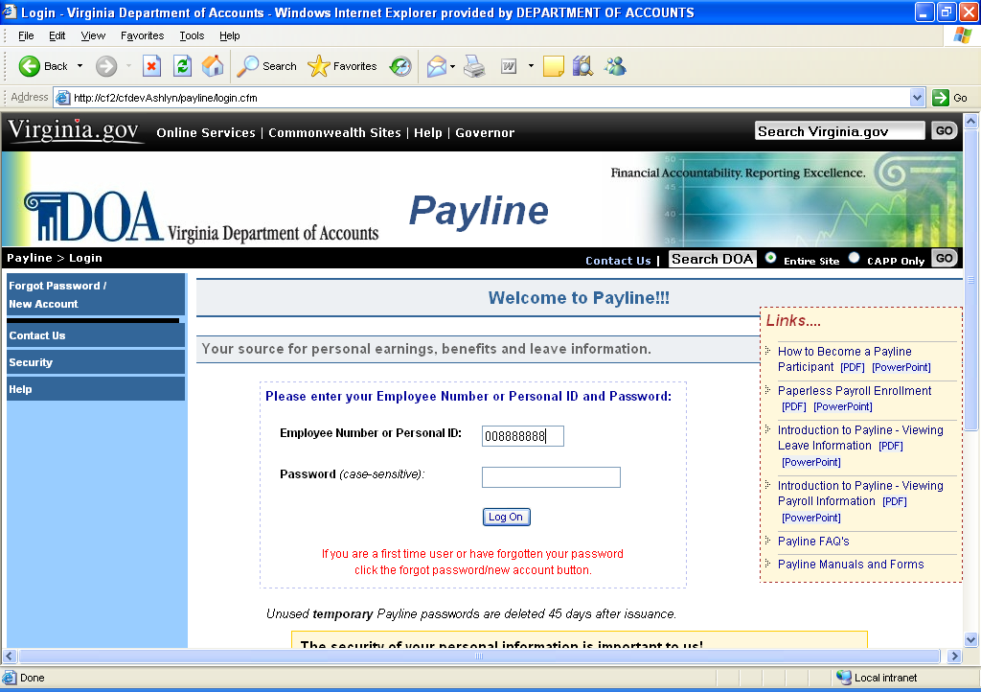

Continued on next page
Accessing Payline, Continued

Using Temporary Password With Pass Phrase – New User, Continued | The employee will then be prompted to enter their personal Pass Phrase or to request a new temporary password if they cannot remember the Pass Phrase.

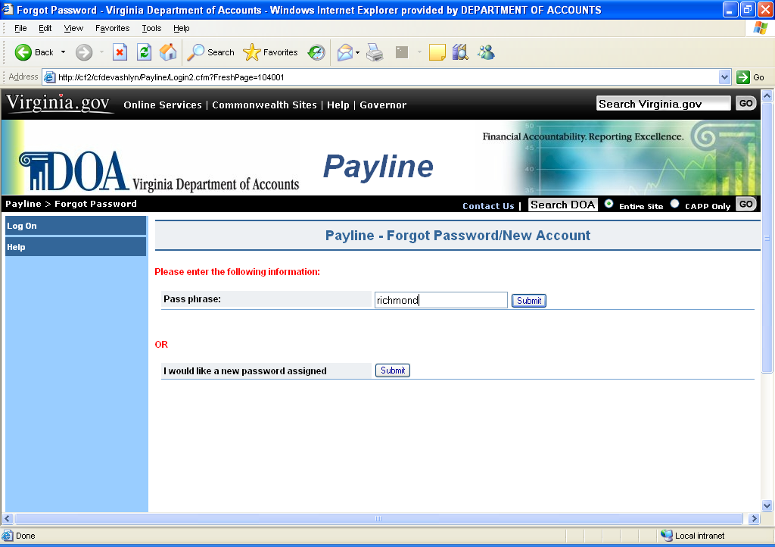

Continued on next page

Accessing Payline, Continued

Using Temporary Password With Pass Phrase – New User, Continued | An information box concerning the security of the personal information contained within Payline will be displayed. After reading the information box, the employee will click Continue to proceed into Payline.

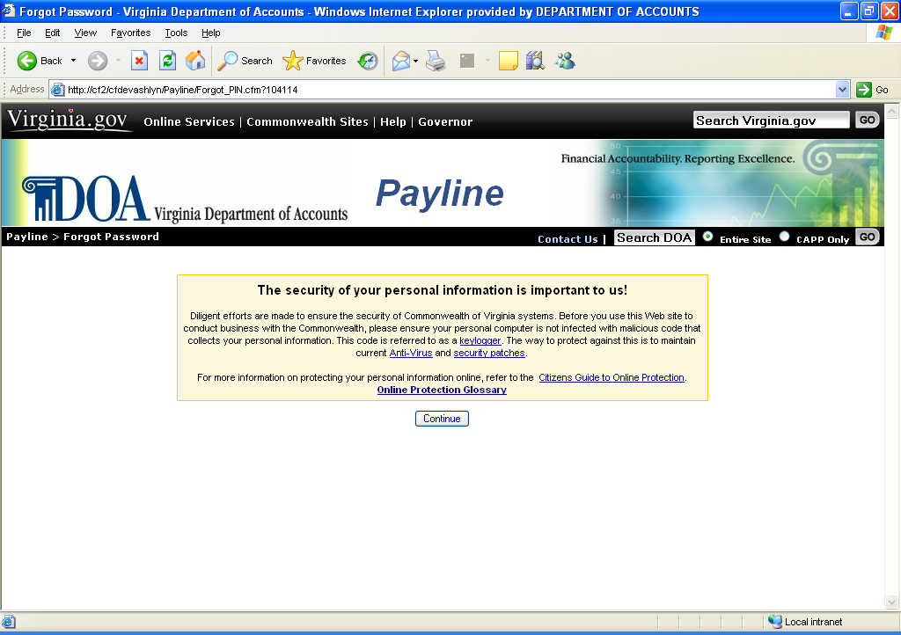

Continued on next page

Accessing Payline, Continued

Using Temporary Password With Pass Phrase – New User, Continued | The employee will be presented with a screen to establish the Personal Options data for their account.

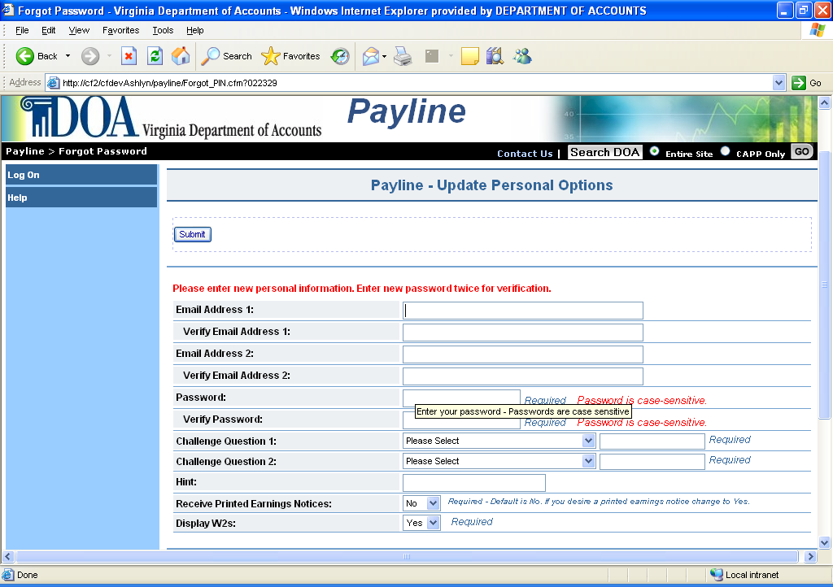

Continued on next page

Accessing Payline, Continued

Using Temporary Password With Pass Phrase – New User, Continued | The Personal Options screen has the following fields available for use.  - The user can enter a Business Email and/or Personal Email address. If an email address is supplied, it will need to be entered a second time for verification.  - The user must enter a password and verify that password by retyping it. The passwords are case sensitive and must follow the Information Security Standards for password management. The standards require passwords to:  1) be at least eight characters in length  2) utilize at least three of the following four:  special characters ( $ ! @ { } & ~ + ? [ ] ),  upper case alphabetical characters (A - Z),  lower case alphabetical characters (a - z),  numerical characters (0-9),  3) not contain spaces  4) not match assigned temporary password  5) not contain ( ' ), ( < ), ( > ), or ( # )  6) not match last 24 passwords  - The employee must answer their choice of any two challenge questions. The challenge questions are used to verify the employee’s identity for various actions within Payline. The challenge answers are not case sensitive. (Note: After the initial set-up changes to question selection and/or answers to questions can only be performed after answering the previously stored challenge questions correctly on the Profile Page.)  - The employee may enter a word or phrase to aid in the recall of the password. This hint will be displayed on the Forgot Password/New Account page.  - The employee can choose whether or not to receive earnings notices if their agency has not opted out agency-wide.  - The employee can opt to disable the display of their W-2s. “No” will disable the display and “Yes” will allow display of W-2s. Employee can change this option later by accessing the Personal Option page.

Continued on next page

Accessing Payline, Continued

Using Temporary Password With Pass Phrase – New User, Continued | Once the user completes the necessary information on this screen, they will press the Submit button and receive notification that their Security Record has been updated. The employee will press the Continue to Payline button. At this point, the user has full access to the services that Payline offers.

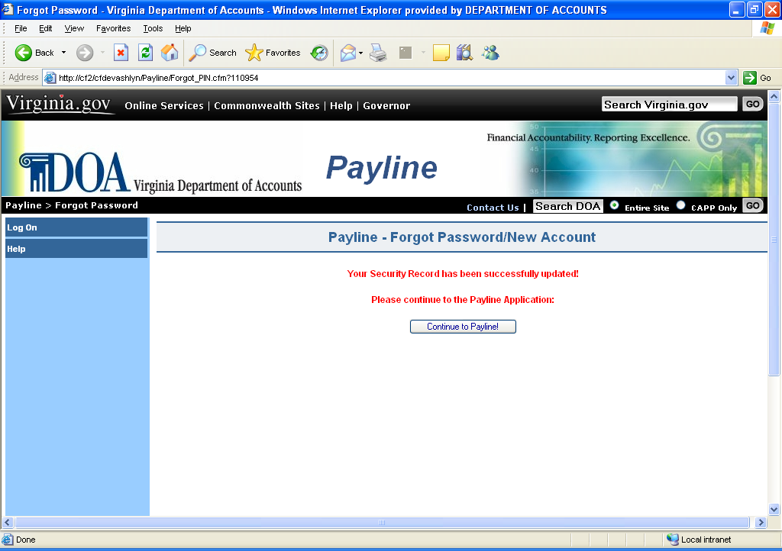

Continued on next page
Accessing Payline, Continued

Invalid User ID | If the employee enters an invalid User ID and a password, they will receive the message “Invalid ID.” The user will need to return to the Payline Log On Screen and enter their correct Employee or User ID. If the user does not know their correct Employee Number, they should contact their agency’s Human Resource/Payroll Office for help in determining their correct ID.

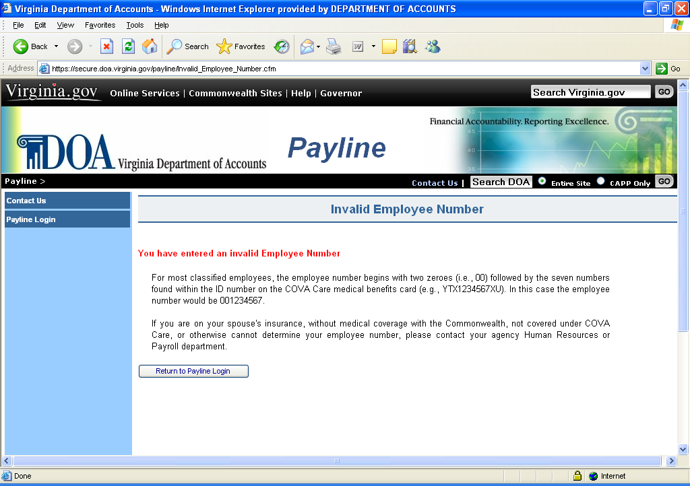

Continued on next page

Accessing Payline, Continued

Forgotten Password | If the employee enters their User ID and an invalid password, they will receive the message “Invalid Password (# of Violations).  NOTE: Passwords are now case sensitive, so please remember to type carefully when entering all passwords.

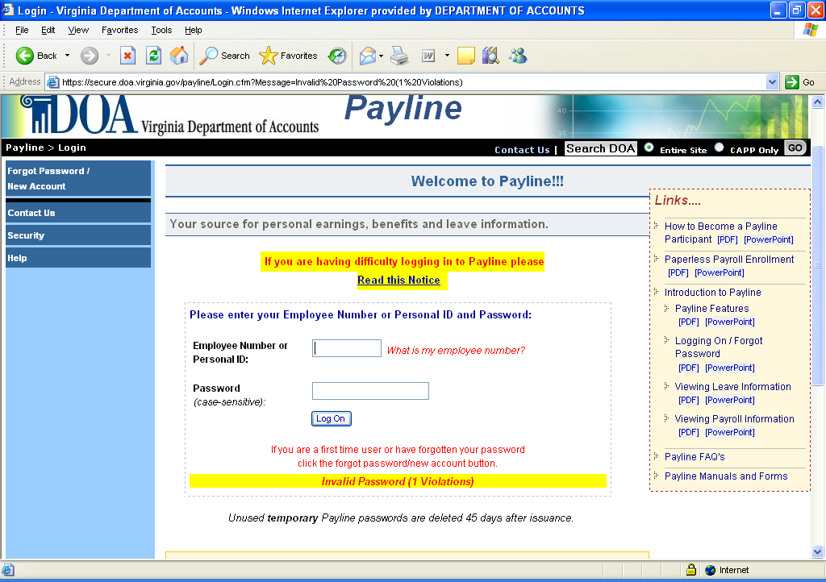

Note: After 5 (five) failed logon attempts the following message is displayed "Account suspended due to security violations." Further, an automated email is generated and sent to the user’s email address (from the Personal Options Page) explaining why the Payline account is suspended.

Prior to reaching the fifth violation, the user may request another temporary password or answer their challenge questions (allows user to change their password immediately) by clicking the ‘Forgot Password/New Account’ button and follow the prompts.

Continued on next page
Accessing Payline, Continued

Forgotten Password, Continued | If the user is not able to remember their password they click on the ‘Forgot Password/New Account’ button then enter the User ID. The user will be shown their previously stored hint. If the hint does not help the user to remember their permanent password, the employee has the choice to receive a new temporary password as follows:  - Answer the challenge questions to store a new password.  - Have a temporary password emailed to a previously stored email address.  - Request a temporary password to be printed on next earnings notice (if agency has not opted out from receiving earnings notices).  - Request a temporary password to be emailed to Payroll and Human Resources Contact.  *Not all options may be available to all employees.

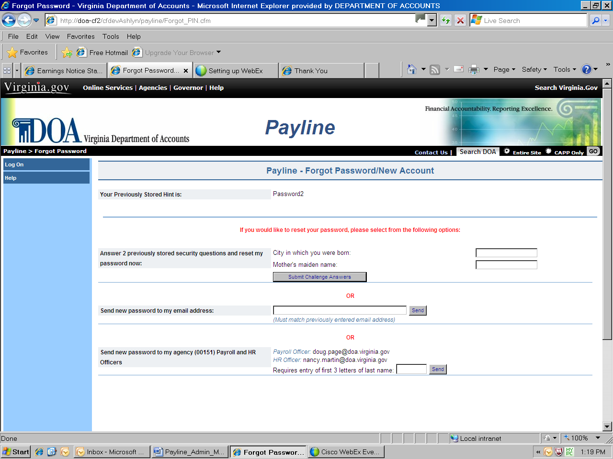

Continued on next page
Accessing Payline, Continued

Challenge Questions for Password Change | The user can enter the answers to the two previously-stored challenge questions and reset their password immediately. Once entered, the employee will press the Submit Challenge Answers button and after acknowledging the security message, the employee will be taken to the Personal Options Page to change their password.

The user will receive a Security Information screen which they should read. Once finished, they will click on the CONTINUE Button.

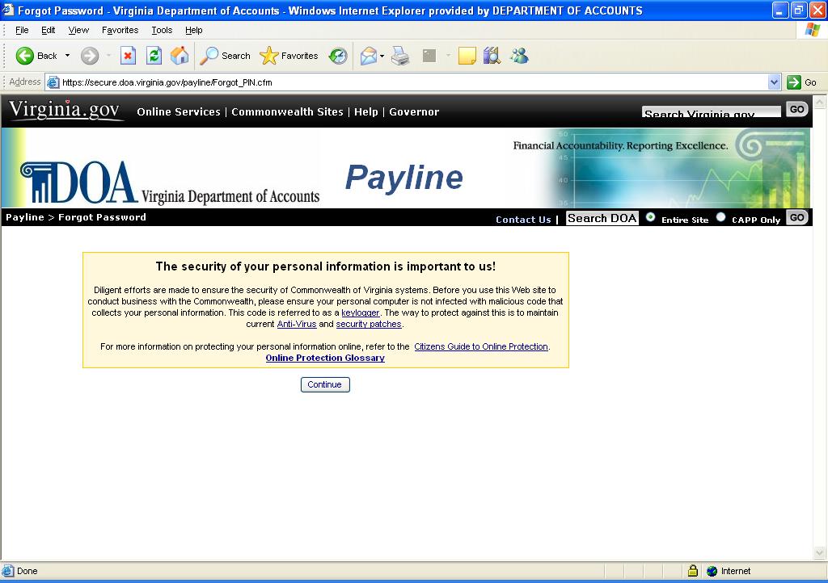

Continued on next page

Accessing Payline, Continued

Challenge Questions for Password Change | Payline will display the UPDATE PERSONAL OPTIONS page. The user:  - Can update their email address(es),  - Must change their password,  - Can update their hint,  - Can choose whether or not to receive earnings notices if their agency has not opted out agency-wide,  - Can opt to disable the display of their W-2s. “No” will disable the display and “Yes” will allow display of W-2s.

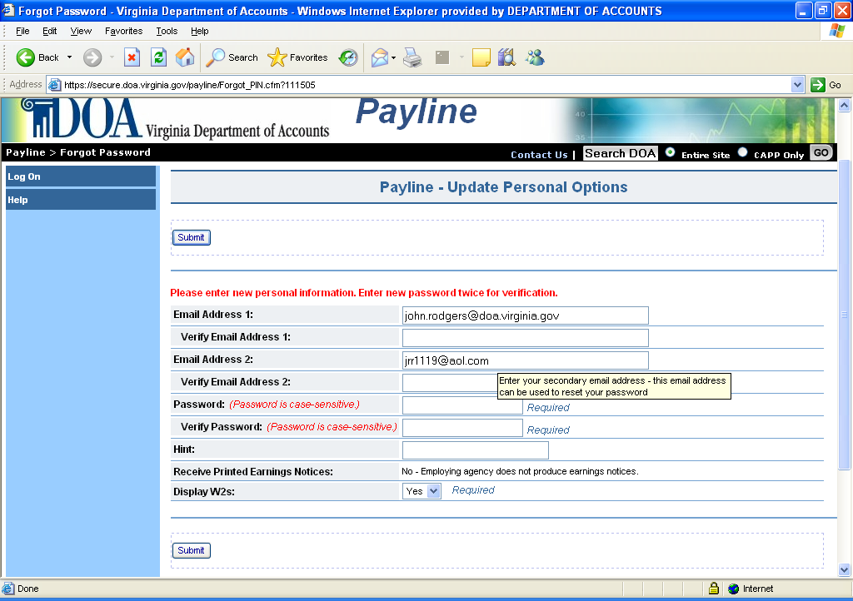

Continued on next page

Accessing Payline, Continued

Challenge Questions for Password Change, Continued | Once the user completes updating this screen, they will click on the SUBMIT button, and will be informed that their Payline Record has been successfully updated.  The employee will press the Continue to Payline button. At this point, the user has full access to the services that Payline offers.

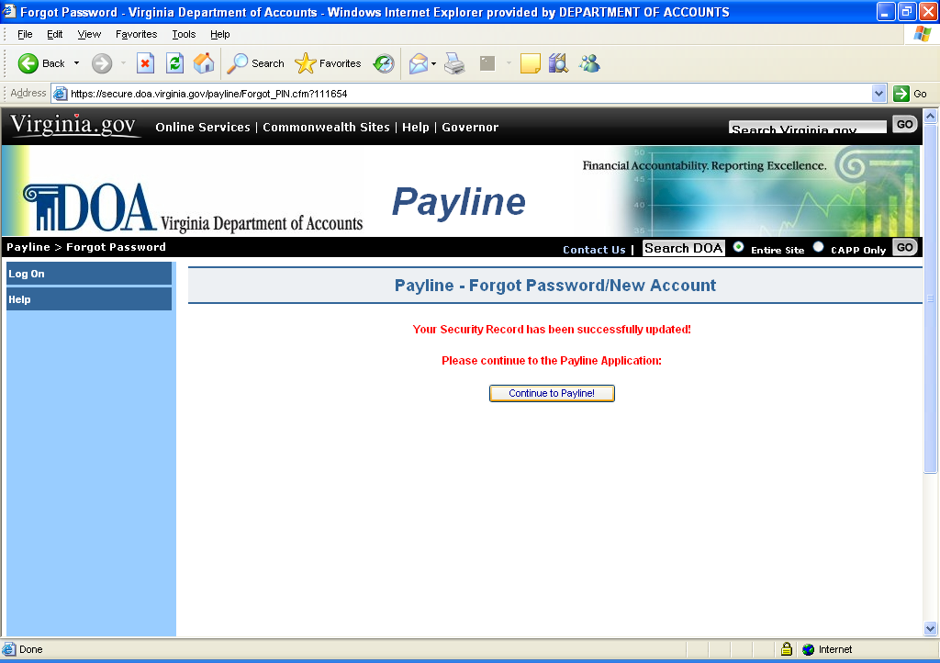

Continued on next page

Accessing Payline, Continued

Email to previously stored address | The user is also given the opportunity have the temporary password emailed to a previously stored email address on the user’s profile.  If the email address does not match one stored on the user’s profile the message, "Email address (the email address entered ) did not match”. The user will then be given an opportunity to re-enter their correct email address.  The user will be required to enter a Personal Pass Phrase to be used in conjunction with the temporary password once it is received.

Continued on next page

Accessing Payline, Continued

After entering the correct email address, the user will click on the "Send' button. If the email address is accepted, the user will view the message “Your new temporary password has be sent to ****************” The employee should receive their new temporary password in a short period of time.

See ‘Using Temporary Password With Pass Phrase – New User’ section for instructions on using the temporary password to enter Payline.

NOTE: Temporary passwords must be typed as shown. Passwords are case sensitive.

Continued on next page
Accessing Payline, Continued

Email to Human Resources/  Payroll Office | The user is also given the opportunity have the temporary password emailed to the Agency’s Payroll Officer by clicking on the appropriate button. The Human Resources/Payroll Office will then forward the temporary password onto the user.  The user will be required to enter a Personal Pass Phrase to be used in conjunction with the temporary password once it is received.

Once the request process is complete, the user will receive the following message:

“Your new temporary password has been e-mailed to your Payroll and HR Officers:
payrollname@agency; hrname@agency”

NOTE: Temporary passwords must be typed as shown. Passwords are case sensitive.

See ‘Using Temporary Password With Pass Phrase – New User’ section for instructions on using the temporary password to enter Payline.

Continued on next page
Accessing Payline, Continued

Print on Earnings Notice | If the agency or individual employee has not opted out of receiving earnings notices, the user can also choose to have their temporary password printed on their next earnings notice.  The user will be required to enter a Personal Pass Phrase to be used in conjunction with the temporary password once it is received.  Once the request process is complete, the user will receive the following message:  “Please look for your new temporary password in the message section of your earnings notice. The message section is just below the detailed earnings and deductions and above the removable check or earnings notice.  It will be accompanied by the message:  “PER YOUR REQUEST, YOUR CONFIDENTIAL TEMPORARY PAYLINE PASSWORD IS:”  And will consist of 8 characters.  NOTE: Temporary passwords must be typed as shown. Passwords are case sensitive.

See ‘Using Temporary Password With Pass Phrase – New User’ section for instructions on using the temporary password to enter Payline.

Continued on next page
Accessing Payline, Continued

General Logon with a Valid Password | The employee enters their Employee ID or Personal ID (both will be referred to as User ID in future) and password and clicks on the Log On button. This links the employee to the Broadcast Messages page for personal messages and other menu selection items.

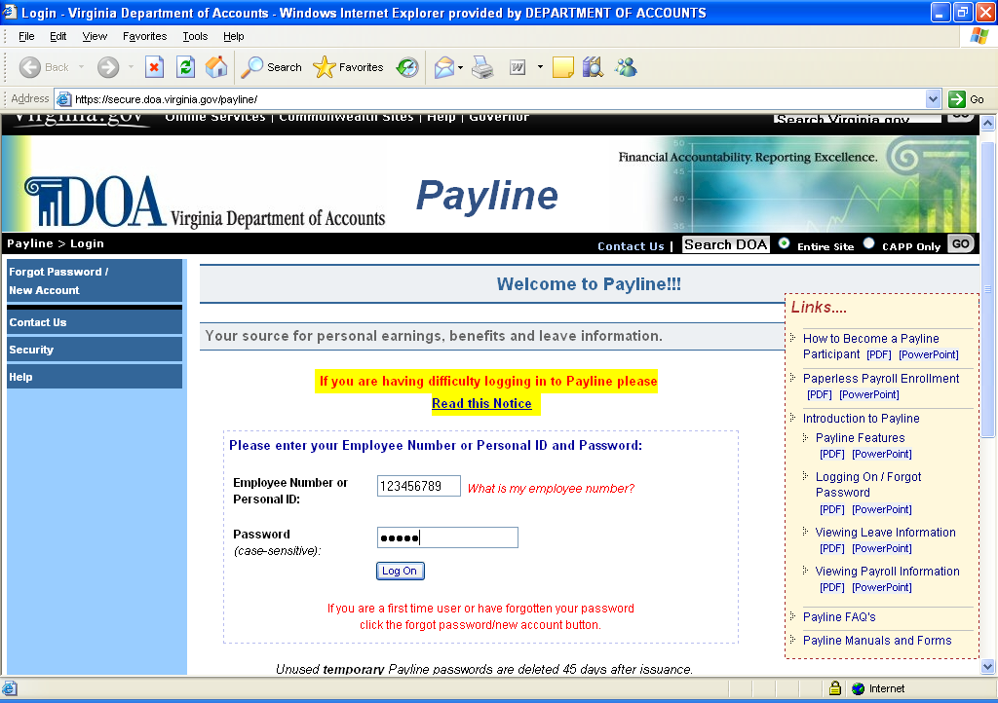

Continued on next page
Accessing Payline, Continued

Step | Action
1 | Enter User ID
2 | Enter the User Password
3 | Click on the Log On button.
If a correct User ID and password are entered, the user enters Payline and the Broadcast Messages page is displayed.

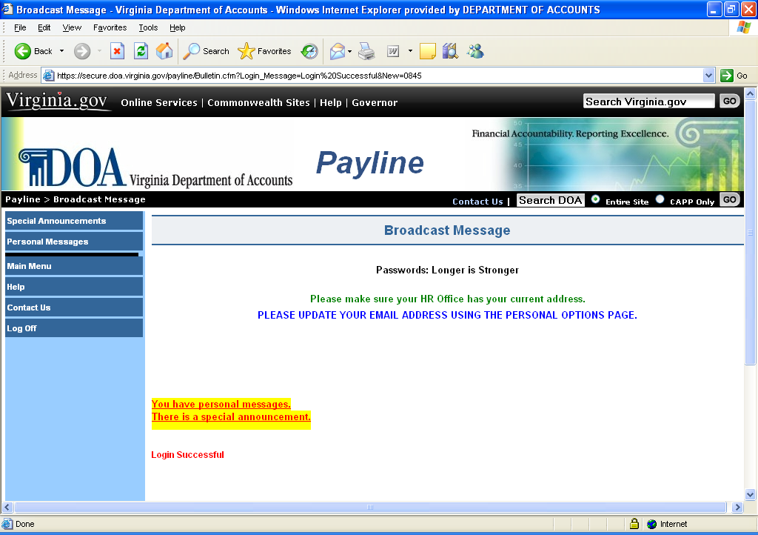

Broadcast Messages Page

Message Pages | The Broadcast Messages page is used to communicate messages both globally and individually to the Payline user population. In the center of the page, a global message intended for all Payline users is displayed. Additionally, in the bottom left hand corner, informational messages may appear which provide feedback to the user regarding actions which have been taken (e.g., Login Successful), and actions which should be taken (e.g., You have personal messages).

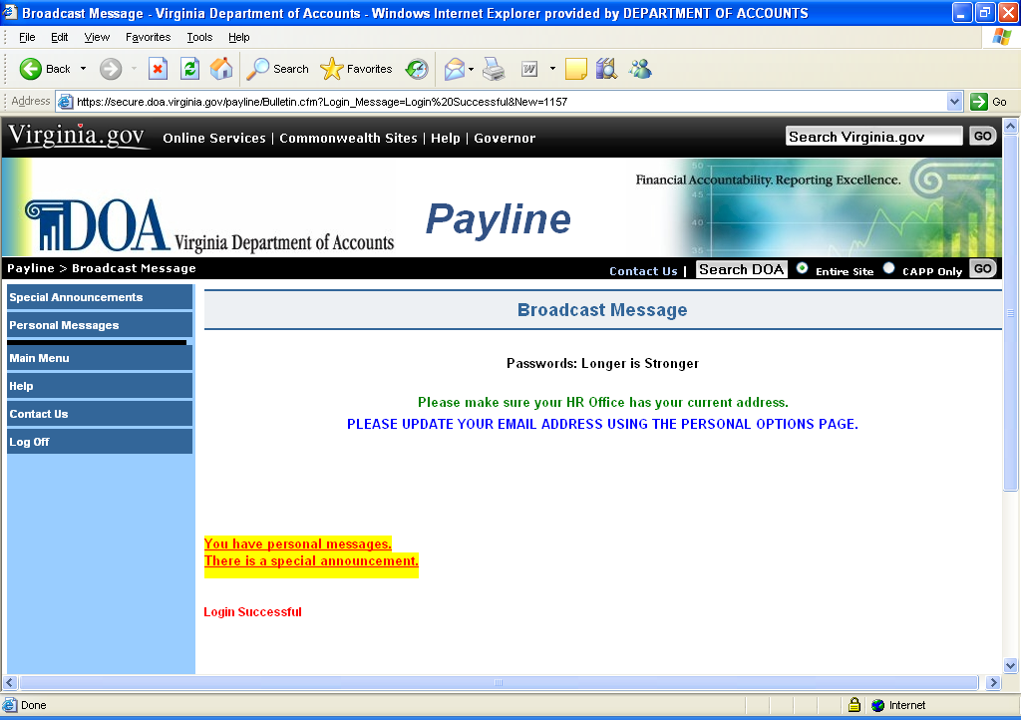

Continued on next page
Broadcast Messages Page, Continued

Navigation | Unique buttons found on this page are described below.

BUTTON | DESCRIPTION
Special Announcement | If a special announcement (e.g., letter from Governor granting additional paid holidays at Christmas) is available for viewing, this button will be displayed. Additionally, the informational message “There is a Special Announcement” will appear in the bottom left corner of the Broadcast Message page. Clicking on this button will link the user to the Special Announcement page displaying additional global announcements directed to all Payline users.
Personal Messages | If a personal announcement is available for viewing, this button will be displayed. Additionally, the informational message ‘You have personal messages’ will appear in the bottom left corner of the Broadcast Message page. Clicking on this button will link the user to the Personal Messages page displaying notices solely for the individual Payline user logged in.

Special Announcements Page

Special Announcement | The Special Announcements page is used to communicate global messages to the Payline user population. These announcements (e.g., letter from the Governor granting additional paid holidays at Christmas), will be displayed in the center of the page.  Payline users may read the announcement by clicking on the ‘Read’ prompt to the left of the message or remove the display of an announcement by clicking on the ‘Delete’ prompt. Any announcement not read or deleted within 30 days will be automatically deleted.
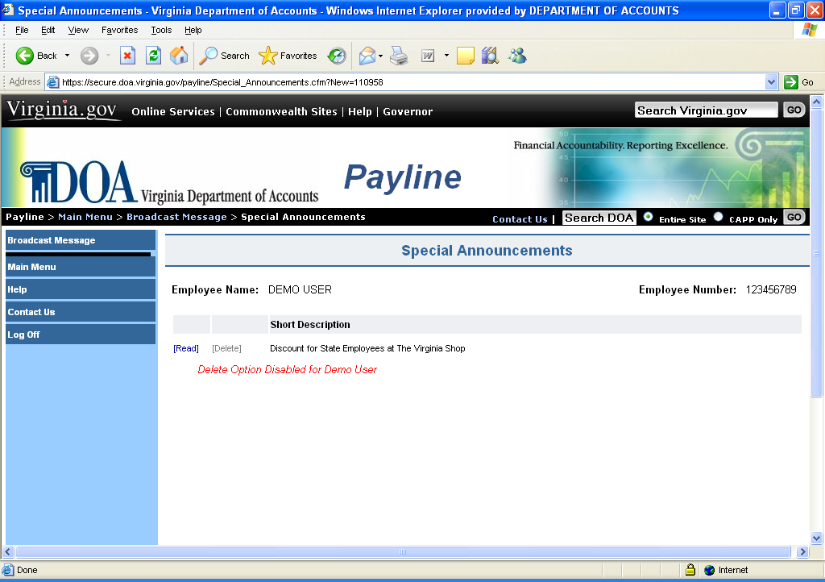

Navigation | Unique buttons found on this page are described below.

BUTTON | DESCRIPTION
Broadcast Messages | Clicking on this button will link the user to the Broadcast Message page.

Personal Messages Page

Personal Messages | The Personal Messages page is used to communicate messages intended solely for the individual Payline user logged on. These messages will be displayed in the center of the page showing: Employee Name, Date of the message, and Message content.  Payline users may remove a message by clicking on the ‘delete’ prompt shown to the left of the Date. An informational message will be displayed stating the message has been deleted. Any message not deleted by the user will automatically be deleted within30 days.

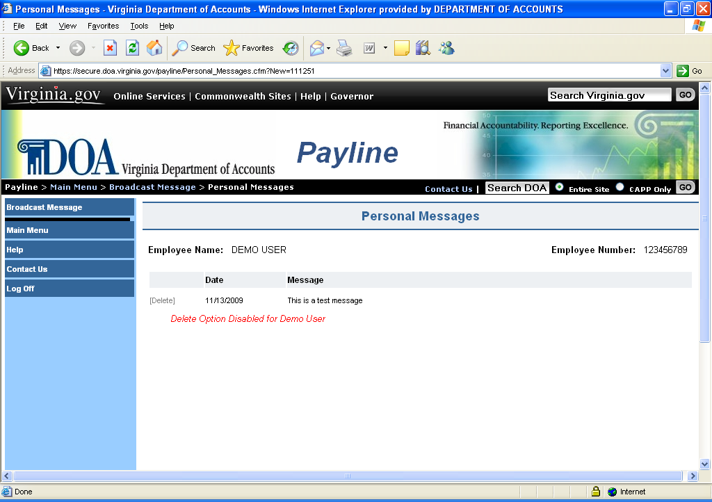

Navigation | Unique buttons found on this page are described below.

BUTTON | DESCRIPTION
Broadcast Messages | Clicking on this button will link the user to the Broadcast Message page.

Main Menu Page

Main Menu | The Main Menu page is the central navigation page for Payline. Navigation buttons located in the left-hand margin of the page link to other Payline pages or perform requested functions as described below.
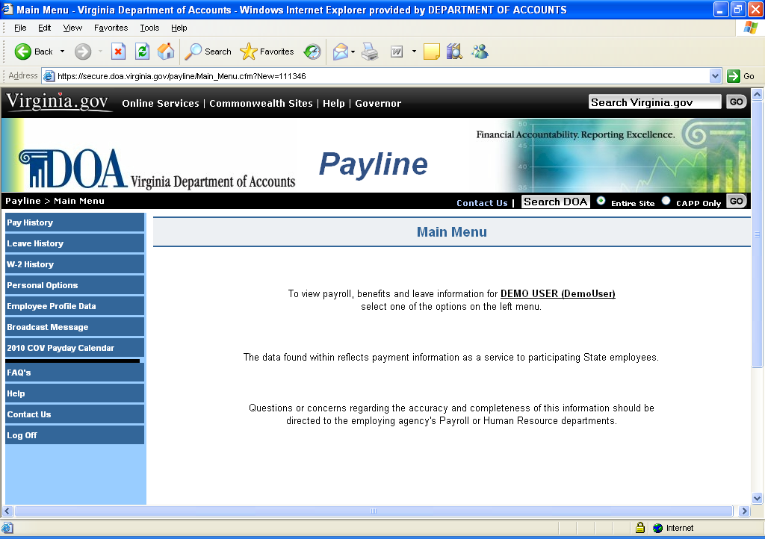

Continued on next page
Main Menu Page, Continued

Navigation | Unique buttons found on this page are described below.

Button | Description
Pay History | Clicking on this button will link the employee to a listing of payroll payment information. From this list, the employee will be able to view a detailed break out of his earnings, deductions, and agency paid benefits along with other personal information. Additionally, a link is provided on this page to view and print a facsimile of the earnings notice.
Leave History | Clicking on this button will link the employee to a listing of leave periods end dates. From this list, the employee will be able to obtain a complete display of their detailed leave balances for each period.
W-2 History | Clicking on this button will link the employee to a listing of W-2s that are available. Additionally, the employee can view and/or print off the W-2.
Personal Options | Clicking on this button will link the employee to a page containing their personal data such as User ID, email addresses, hint, ability to opt out of receiving earnings notices and password. Changes to the employee’s Payline information are made on this page.
Employee Profile Data | Clicking on this button will link the employee to a page containing the employee’s name, address, and tax elections. Employees may request changes through to this information on this page, however, agencies may require further documentation.
Broadcast Messages | Clicking on this button links the employee to the Broadcast Messages page where global and individual messages for all Payline users can be viewed.
COV Payday Calendar | Clicking on this button links the employee to the Commonwealth of Virginia’s Pay and Holiday Calendar.

Personal Options Page

View Personal Options | The View Personal Options page allows Payline users to view the existing information regarding their:  - Employee Number (cannot be edited)  - Personal ID  - Password (the actual password is not displayed, but an * indicates it does exist.)  - Email Address 1  - Email Address 2  - Challenge Question1  - Challenge Question 2  - Hint (to help in remembering current password.)  - Rec Earnings Notice (Election regarding receiving a printed earnings notice)  - Display W-2 option  - Date Password Changed - reflects last date your password was altered.(cannot be edited.)  To edit this information simply click on the Edit Personal Options button at the top of the page.

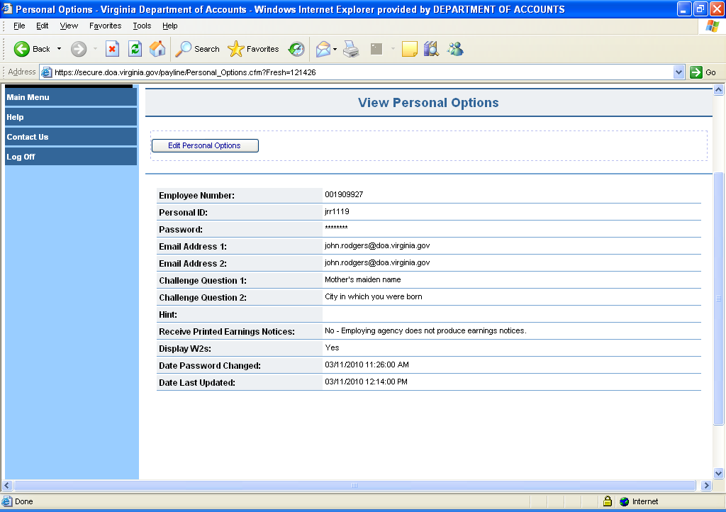

Continued on next page
Personal Options Page, Continued

Personal ID | Enter a Personal ID of your choice between 5 and 8 characters. This Personal ID can be used in lieu of employee number when logging in to Payline or when requesting a forgotten password. (This field is optional.)
 |  | Step | Action
 |  | 1 | Click on Edit.
 |  | 2 | Enter the 5-8 character personal ID of your choice.
 |  | 3 | Click on Accept.
 |  | 4 | Receive message “Record Updated”

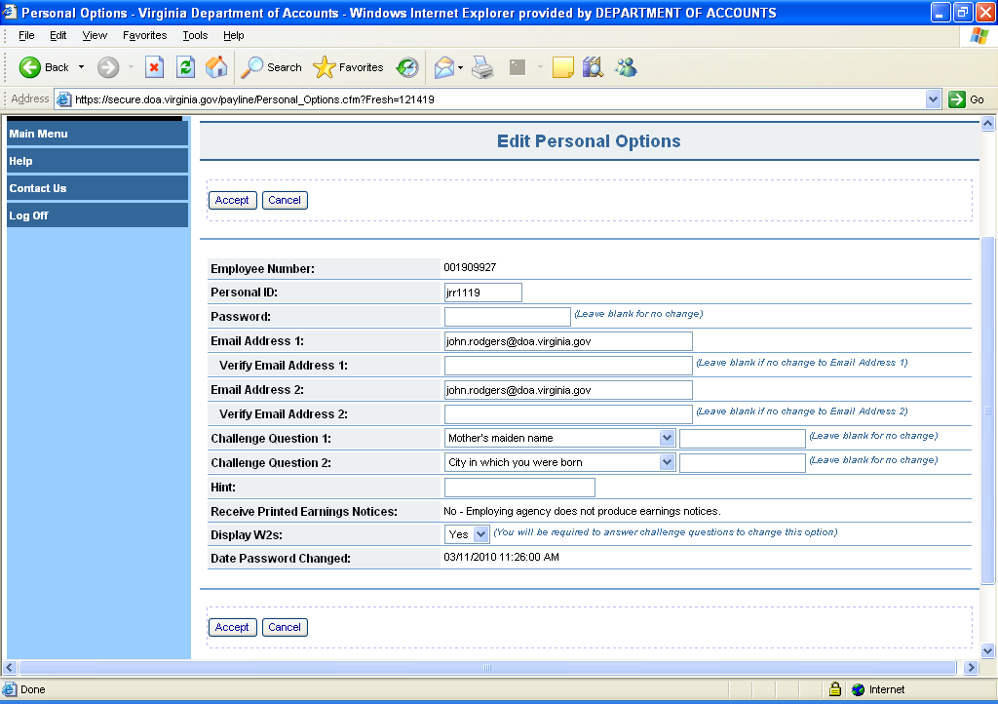

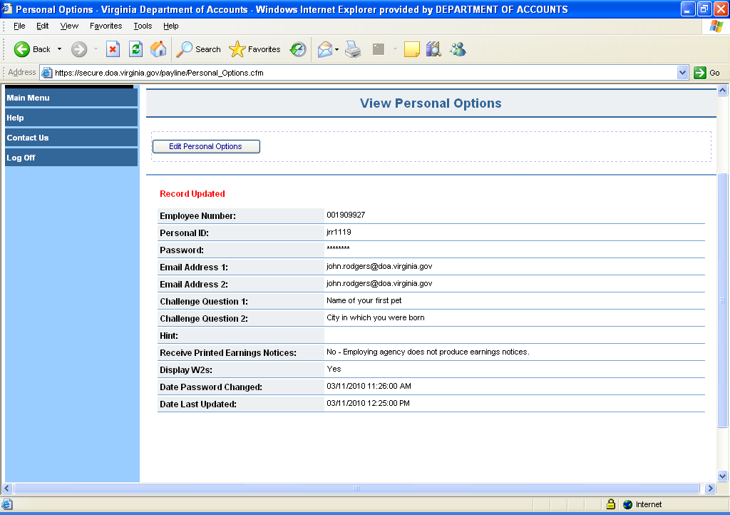

Continued on next page
Personal Options Page, Continued

Password | The user must enter an unique password and verify that password by retyping it. The passwords are case sensitive and must follow the Information Security Standards for password management.  Passwords are case-sensitive.  Password must:  1) be at least eight characters in length  2) utilize at least three of the following four:  special characters ( $ ! @ { } & ~ + ? [ ] ) _,  upper case alphabetical characters (A - Z),  lower case alphabetical characters (a - z),  numerical characters (0-9),  3) not contain spaces  4) not contain ( ' ), ( < ), ( > ), or ( # )  5) not match assigned temporary password  6) not match last 24 passwords

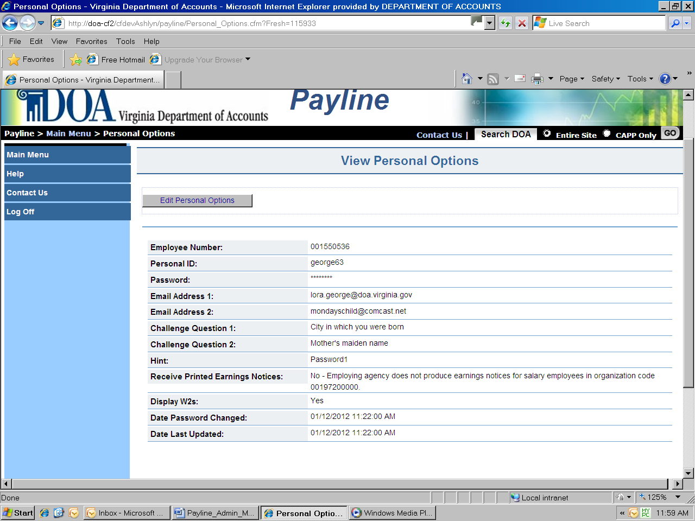

Continued on next page
Personal Options Page, Continued

Step | Action
1 | Click on Edit.
2 | Enter the 8-18 character personal password of your choice. Must meet guidelines stated above.
3 | Validate the password you entered (Verify Password)
4 | Click on Accept.
5 | Receive message “Record Updated”

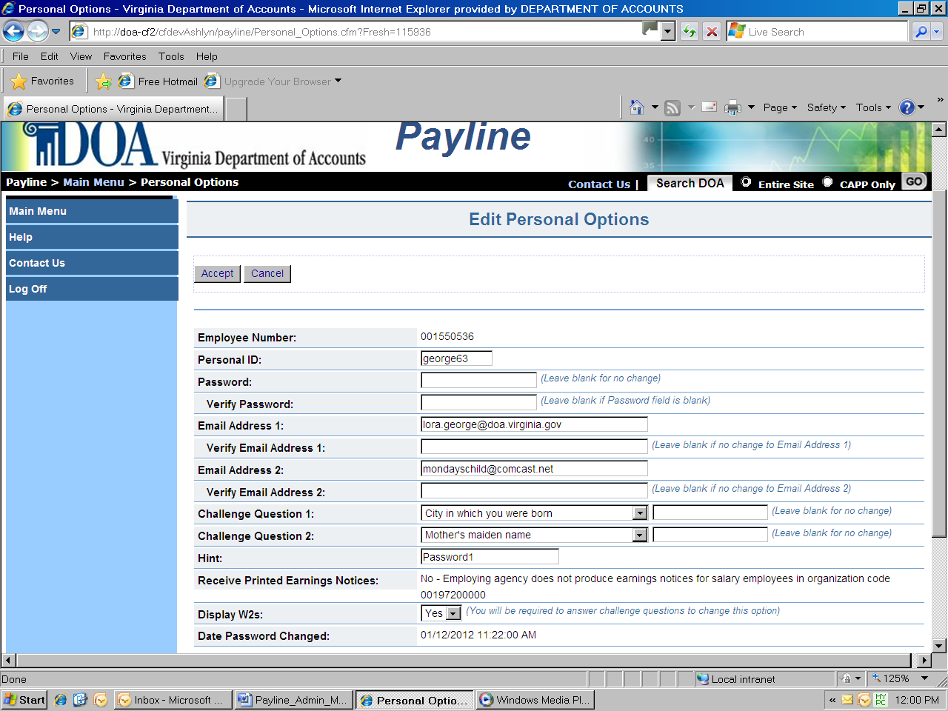

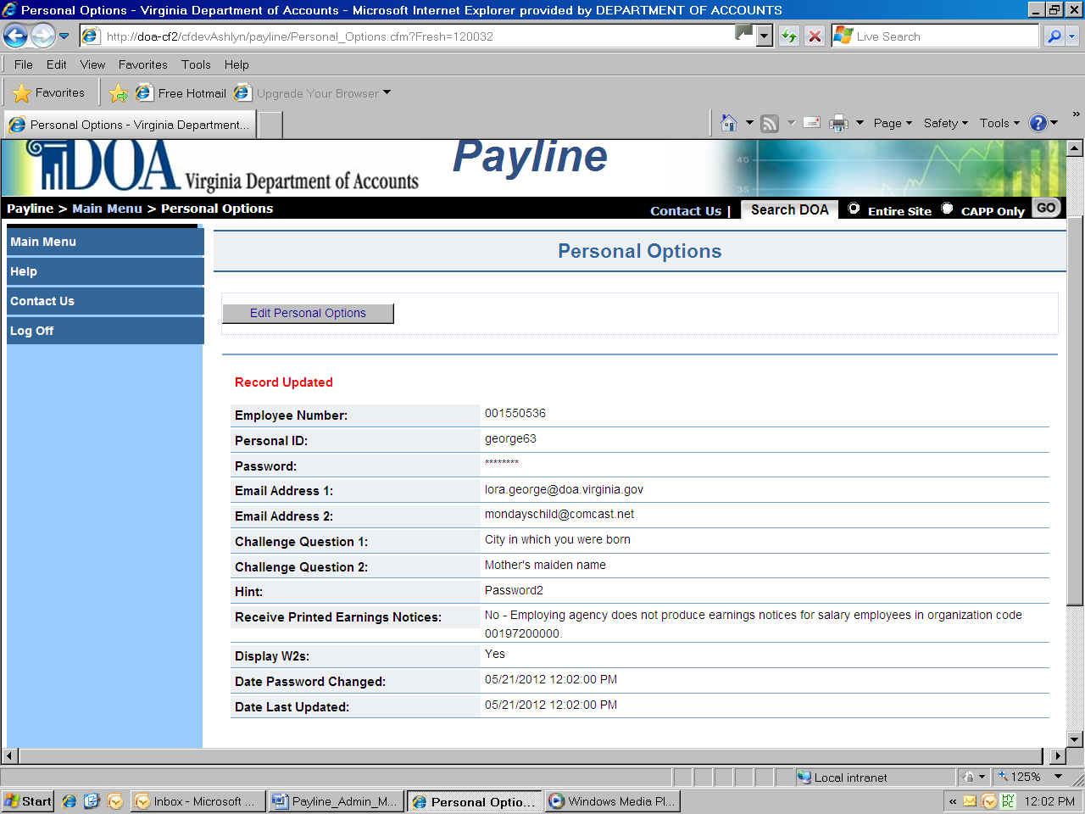

Continued on next page
Personal Options Page, Continued

Email Address 1 & 2 | Enter your primary and/or secondary email address.  Either email address can be used to reset your password if you would like to avoid waiting to receive forgotten passwords on an earnings notice.  Email Addresses are not case-sensitive.

Continued on next page
Personal Options Page, Continued

Step | Action
1 | Click on Edit.
2 | Enter the email addresses you wish to update.
3 | Validate the email address(es) you entered.
4 | Click on Accept.
5 | Receive message “Record Updated”

Continued on next page
Personal Options Page, Continued

Challenge Questions | Challenge questions are used to verify your identity when resetting your challenge questions or changing you Display W-2s option. Select two challenge questions and enter your answers in the boxes provided. The challenge answers are not case-sensitive.

Continued on next page
Accessing Payline, Continued

Step | Action
1 | Click on Edit.
2 | Select the Challenge Question(s) you wish to change.
3 | Type in answer(s) to Challenge Question(s).
4 | Click on Accept.
5 | Answer your previous Challenge Questions.
6 | Click on Submit.
7 | Receive message “Record Updated”

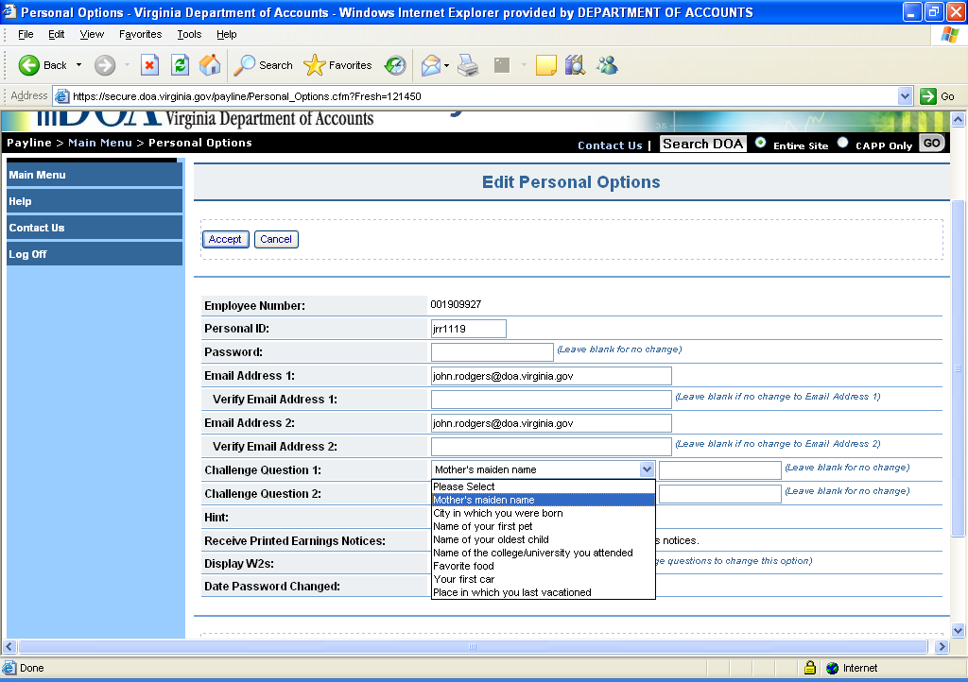

Continued on next page
Personal Options Page, Continued

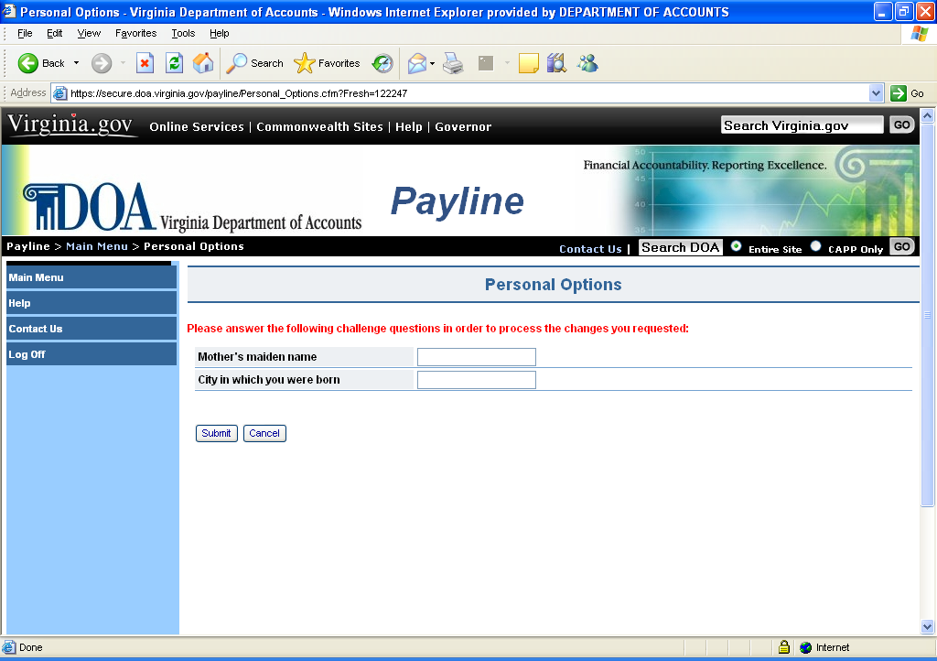

Continued on next page
Accessing Payline, Continued

Hint | Enter a word or phrase that will help you to remember your password. This hint will be displayed on the Forgot Password/New Account page. Hint is not case-sensitive.  Field is optional.

Continued on next page
Personal Options Page, Continued

Step | Action
1 | Click on Edit.
2 | Enter a word or phrase (up to 25 characters) for a hint.
3 | Click on Accept.
4 | Receive message “Record Updated”

Continued on next page
Personal Options Page, Continued

Receive Earnings Notices | If you are a direct deposit participant, you can elect to stop/start the hard copy print of your earnings notice. Most agencies have opted not to allow the hard copy print of earnings notices, so this function is not available to all users.  There are no screen prints available of this option, but the steps will suffice to walk the user through the process.

Continued on next page
Personal Options Page, Continued

Step | Action
1 | Click on Edit.
2 | Select “YES’ to receive printed Earnings Notices. Select “NO’ not to receive printed Earnings Notices.
3 | Click on Accept.
4 | Receive message “Record Updated”

Continued on next page
Personal Options Page, Continued

Display W-2s | Individual W-2s are stored in Payline (See W-2 History selection on Main Menu) and display the user’s Social Security Number. This option will allow the user to Select "No" to disable the display of your W2's or "Yes" to allow W2's to be displayed.  Changing this will require answering previously stored Challenge Questions.

Continued on next page
Personal Options Page, Continued

Step | Action
1 | Click on Edit.
2 | Select “YES’ to view W-2s. Select “NO’ to disable display of W-2s.
3 | Click on Accept.
4 | Answer your previously stored Challenge Questions.
6 | Click on Submit.
7 | Receive message “Record Updated”

Continued on next page
Personal Options Page, Continued

Pay History Screen

Pay History | The Pay History page provides a listing of payroll payments displaying the payment date, agency name and pay period date. (The complete history listing can be viewed by using the scroll bar.) The payment indicator denotes the type of payment represented. This may be one of three values. A blank denotes a typical payment made in the form of a check or direct deposit. A "VC' represents the reversing or voiding of one of those payments due to processing errors, retrievals of the payment due to time lost from work, or perhaps a lost payment. A "NP" represents a transaction entered into the payroll system to record a payment made outside of the payroll system. This is considered a "non-paid" payment as the actual payment was made through petty cash or some other mechanism.

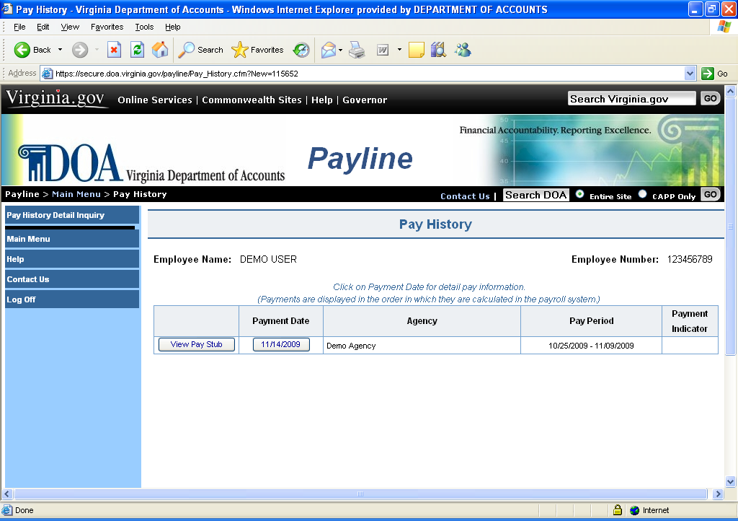

NOTE 1: If an employee has multiple pay instruments for one payment date, all payment information will be collated into one record.

NOTE 2: Voids (VC) and non-paid manual paysets (NP) are listed separately.

NOTE 3: See Attachment A for a crosswalk of standard deduction and earnings descriptions from CIPPS to Payline.

Continued on next page

Pay History Screen, Continued

Navigation | Unique buttons found on this page are described below.

Button | Description
Pay History Detail Inquiry | Clicking on this button links the employee to a page where they may perform a query of specific payment information for a range of check dates.
View Pay Stub | Clicking on this links the employee to a facsimile of the pay stub which can be viewed and printed. The leave displayed will reflect the prior leave balance as is currently reflected on paper earnings notices. See example which follows:
Payment Date | Clicking on this button links the employee to the corresponding Payment information page.

Continued on next page
Pay History Screen, Continued

View Pay Stub | Clicking on this button will display the employee’s payment information in a printable format.

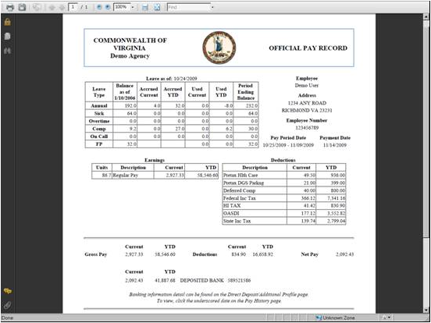

Financial Institutions should accept a printed pay stub from Payline as it contains both:

- the statement "Offical Pay Record" and
- the State Seal of Virginia (Use of the State Seal must be granted by the Secretary of Administration.)

Pay History Detail Inquiry

Pay History Detail Inquiry | The Pay History Detail Inquiry page provides the Payline user the ability to inquire about all pay types, deductions (employee and employer paid), healthcare/retirement plans, federal/state tax elections, and direct deposit information for a specific time period. The information presented is determined by clicking on the radio buttons corresponding to the type of information to be displayed and entering the specified beginning and ending check dates for the inquiry. By checking “All Details” box, all available information will be displayed. Alternatively, selection of one or more specific radio buttons can limit the information displayed. If the results do not display the information the user is looking for the user may need to enter a new range of dates and submit the inquiry again.
 | Printing: If the ALL DETAILS option is chosen or if numerous radio buttons are selected, the user will not be able to print all the information shown. Limiting your selections will allow for printing of the requested information.

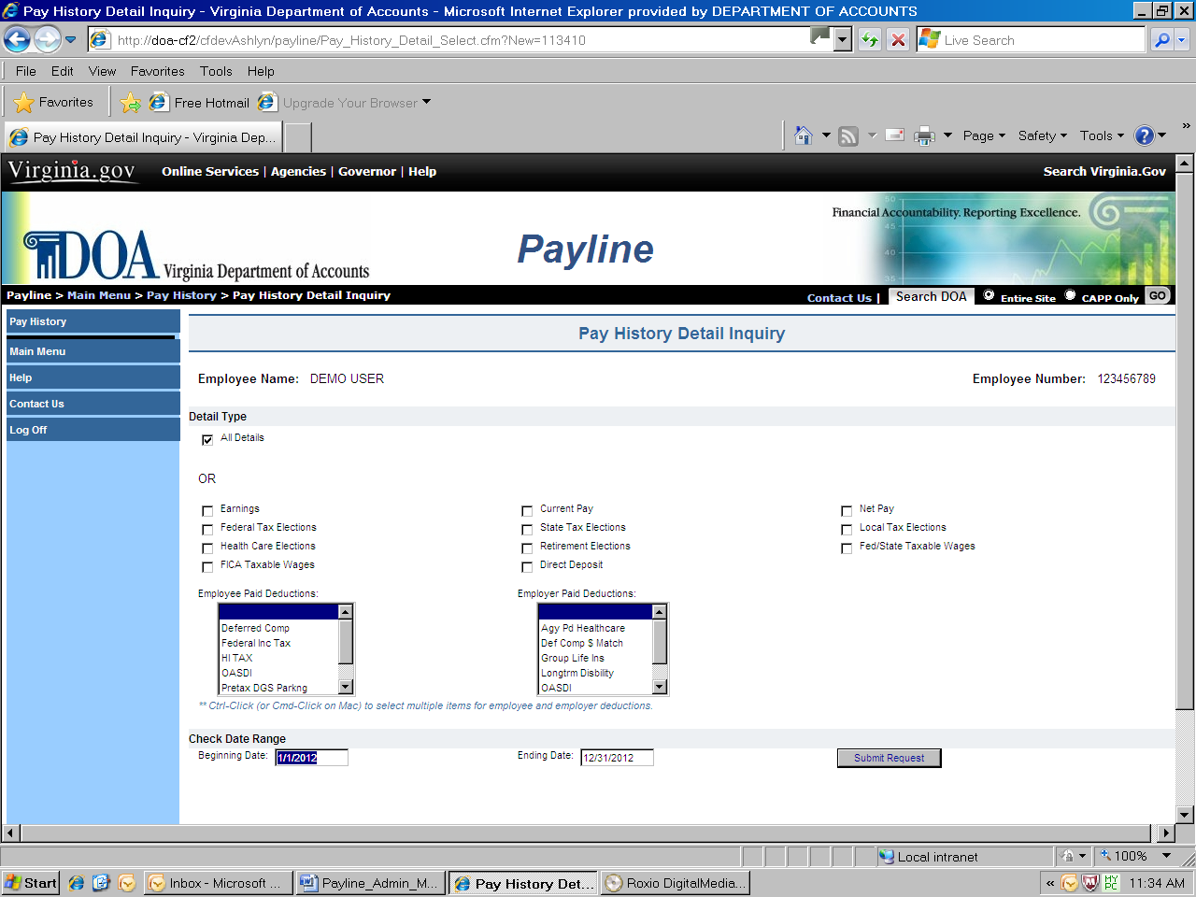

Continued on next page

Pay History Detail Inquiry, Continued

Navigation | Unique buttons found on this page are described below.

Button | Description
Submit Request | Clicking on this button submits the user request and display the results.
Pay History | Clicking on this button returns the employee to the listing of payments by payment date, agency and pay period. Detail of each payment can be displayed by clicking on the payment date.

Steps to Perform Request | Step | Action
Steps to Perform Request | 1 | Select the type of Pay History Detail Inquiry desired by checking the associated selection box.  - All Details - displays all detailed information available for the employee for the check date range provided; or  - Select specific detailed information to be displayed for the check date range provided.
Steps to Perform Request | 2 | Date Range - complete the beginning and ending check dates for the range to show the requested Pay History Detail Inquiry transaction(s).
Steps to Perform Request | 3 | Click on the Submit Request button.
Steps to Perform Request | 4 | Review the Pay History Detail Inquiry Results Screen.

Note: To select deductions use Ctrl-Click (or Cmd-Click on Mac) to select multiple items for employee and employer deductions.

Continued on next page
Pay History Detail Inquiry, Continued

An example of a pay history query requesting specific detailed information is displayed below.

Pay History Detail Inquiry Results | 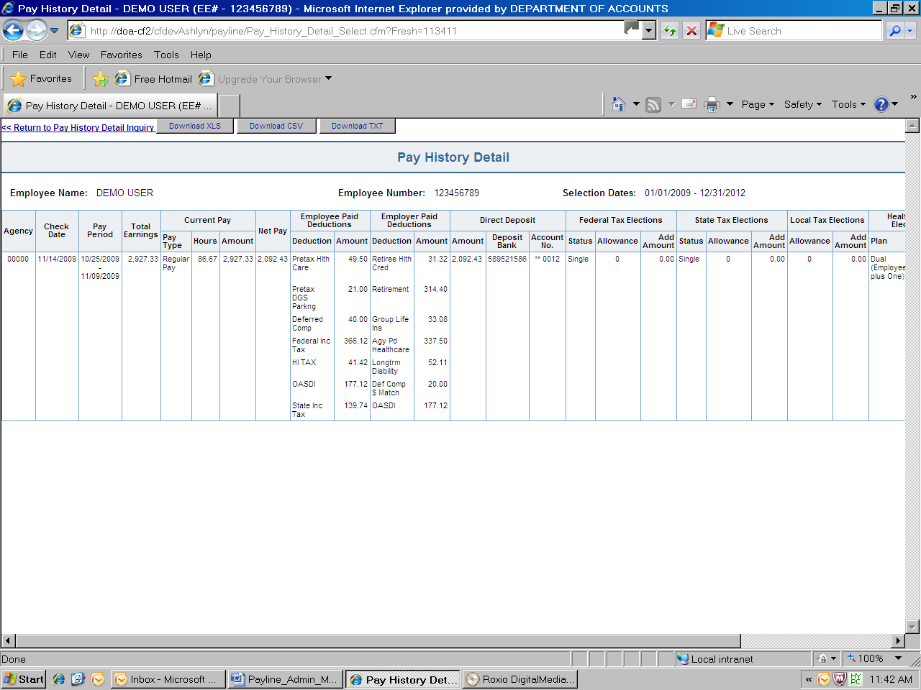

Once the results are displayed, the employee can:
- Print the results as shown on the screen.
- Download the results in an .XLS format.
- Download the results in a CSV format.
- Download the results in a .TXT format.
- Return to the Pay History Detail Inquiry page.

By clicking on the appropriate button or underscored text.

Payment Information

Payment Information | The Payment Information page displays a detailed breakout of earnings, deductions and net pay as well as a summary of agency paid contributions to benefits and taxes corresponding to the payment selected on the Pay History page.

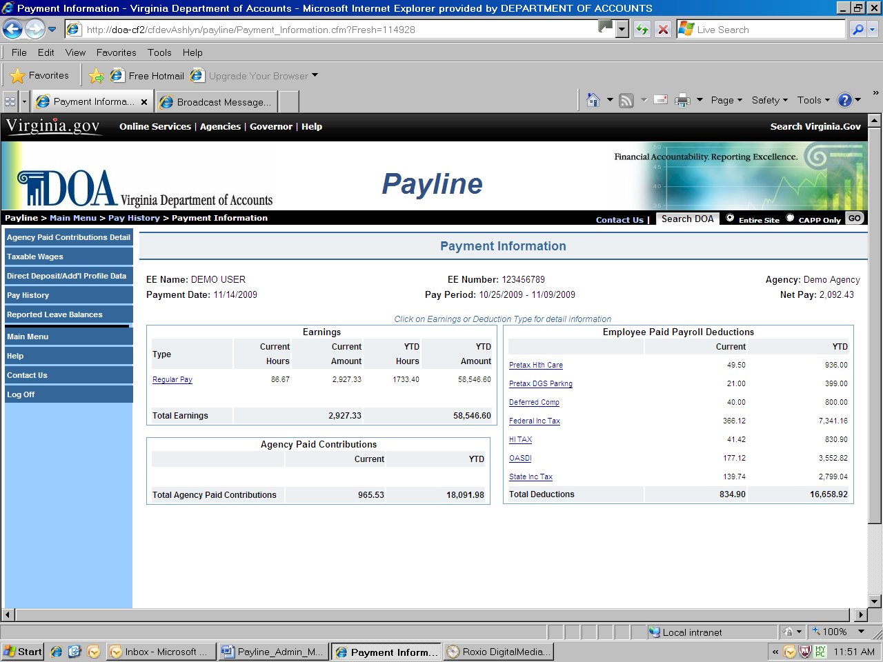

Within the Earnings box a detailed breakdown of Total Earnings is displayed. The detail provided includes:
- Earnings type
- Current and YTD hours
- Current and YTD amounts

Within the Employee Paid Payroll Deductions box a detailed breakdown of employee deductions is displayed. The detail provided includes:
- Deduction type
- Current amount
- YTD amount.

Continued on next page

Payment Information, Continued

Within the Employer Paid Contributions box a summary total of the employer paid benefits is displayed. The detail of this can be found using the “Agency Paid Contributions Detail” button found in the left-hand side of the page.

Navigation | Unique buttons found on this page are described below.

Button | Description
Agency Paid Contributions Detail | Clicking on this button links the employee to a presentation of agency paid contributions to benefits and taxes corresponding to this Payment Information page.
Presentation of Taxable Wages | Clicking on this button links the employee to a presentation of how federal, state and FICA taxable wages were determined as it corresponds to this Payment Information.
Direct Deposit/Add’l Profile | Clicking on this button links the employee to a presentation of how direct deposit monies are distributed, federal and state tax filing status, and health care and retirement elections corresponding to this Payment Information page
Pay History | Clicking on this button returns the employee to their listing of payments by payment date, agency and pay period.
Reported Leave Balances | If leave balances are available for viewing for this payment, this button will be displayed. Clicking on this button will display all leave balances reported with this Payment Information.
TYPE | A description of each earnings and deduction can be displayed by placing the mouse pointer on the earnings or deduction name and clicking the left-mouse button.

Continued on next page

Agency Paid Contributions Detail

Agency Paid Contributions Detail | The Agency Paid Contributions Detail page displays a detailed presentation of current and year-to-date agency paid contributions to benefits and taxes for the payment date selected.

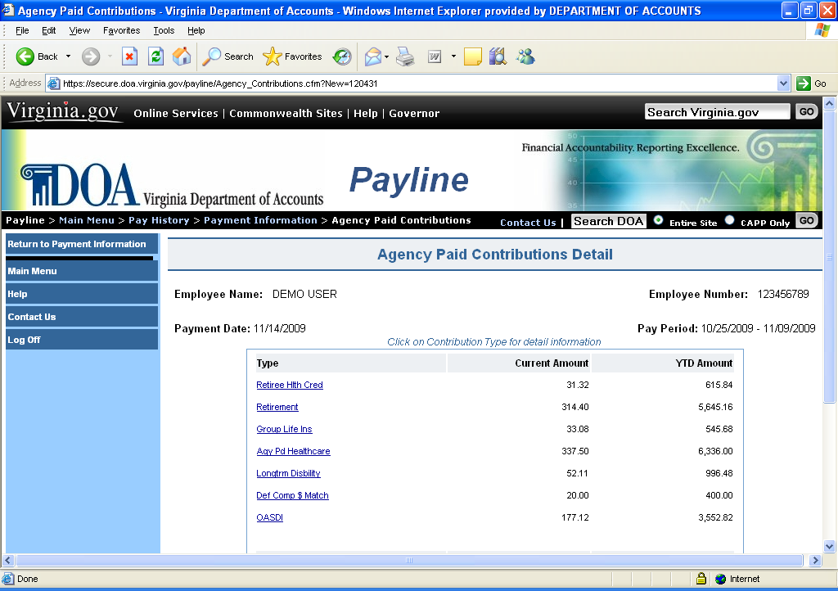

Navigation | Unique buttons found on this page are described below.

Button | Description
Return to Payment Information | Clicking on this button returns the employee to the Payment Information page previously viewed.
Type | A description of each agency paid benefit can be displayed by placing the mouse pointer on the benefit name and clicking one time with the left mouse button.

Presentation of Taxable Wages

Presentation of Taxable Wages | The Presentation of Taxable Wages page displays how federal, state and FICA taxable wages were calculated for the payment selected on the Pay History page. The year-to-date values shown are as of the time that payment was calculated. Total Earnings are reduced by those non-taxable earnings and pre-tax deductions to which some taxes are not applied.
 | NOTE: The information presented displays the employee’s actual YTD accumulations and a “standard” employee profile.
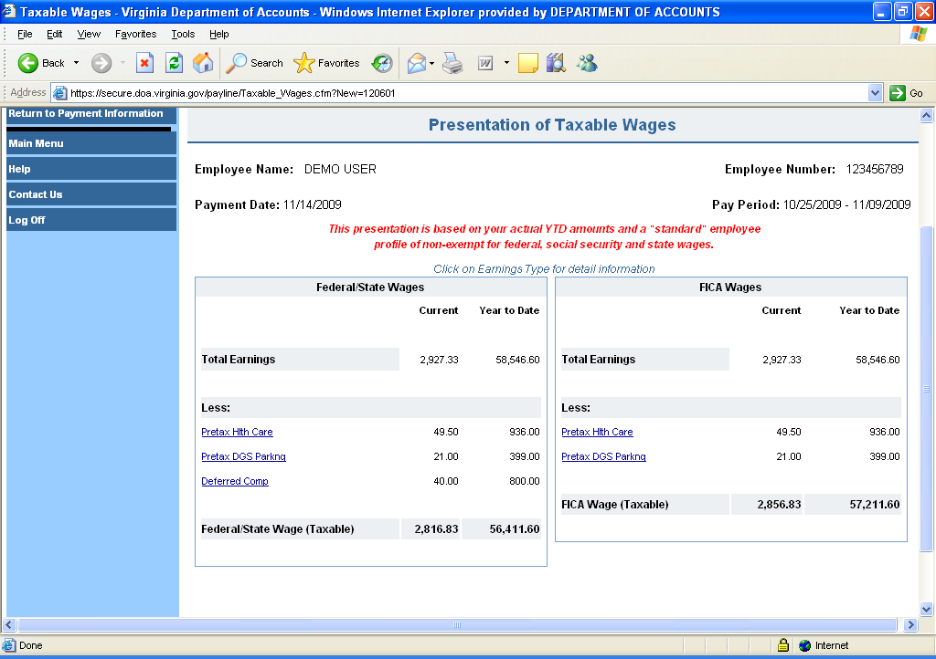

Navigation | Unique buttons found on this page are described below.

Button | Description
Return to Payment Information | Clicking on this button returns the employee to the Payment Information page previously viewed.
Type | A description of each pre-tax item can be displayed by placing the mouse pointer on the benefit name and clicking one time with the left mouse button.

Direct Deposit Detail and Additional Profile Data

Direct Deposit Detail and Add'l Profile Data | The Direct Deposit Detail and Additional Profile Data page displays additional personal information related to the payment selected from the Pay History page.  - Direct Deposit Bank Information – the amount, the deposit bank (ABA routing #) and account number where the deposit has been made.  - Health Care and Retirement Elections – the name of the provider and the membership type elected by the employee for health care and the retirement plan the employee is enrolled in.  - Employee Tax Elections – the employee’s federal, state and local tax withholding elections submitted on Form W-4 and VA-4.

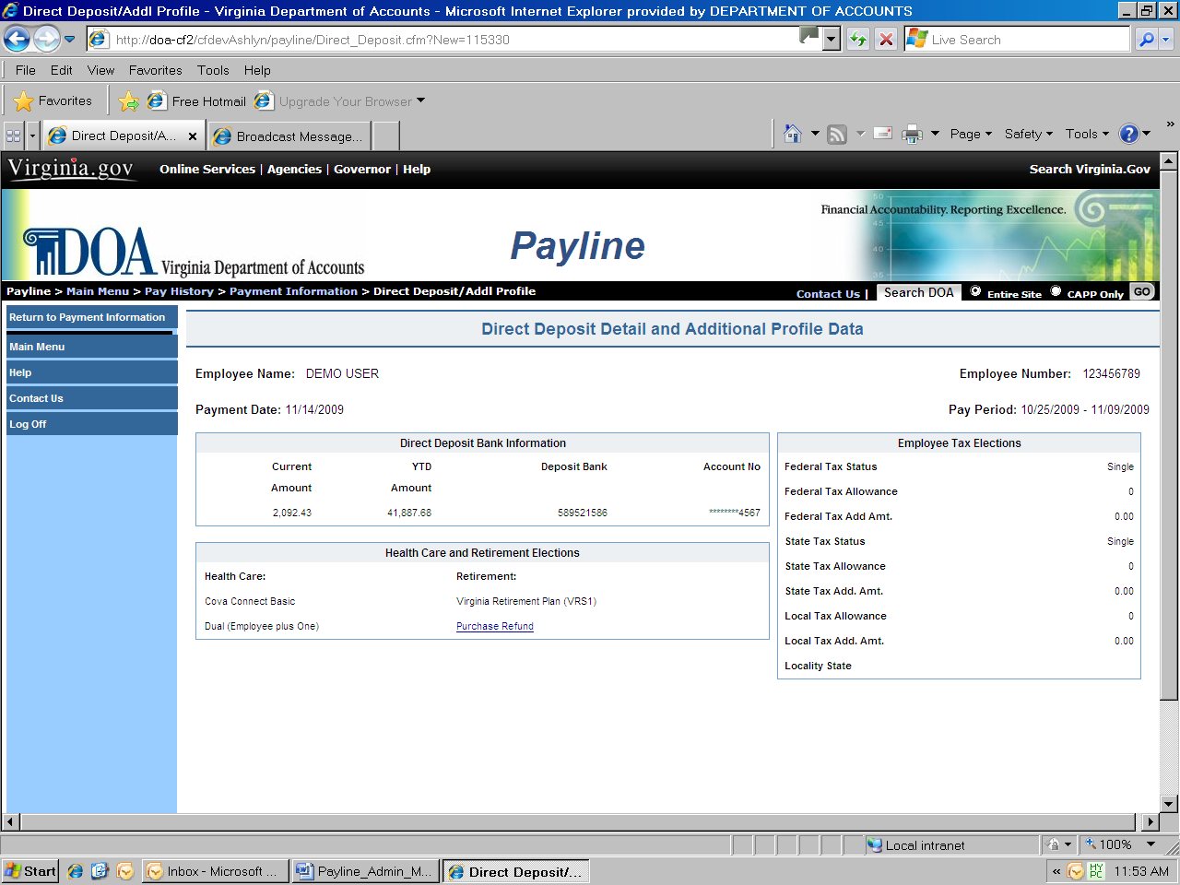

Navigation | Unique buttons found on this page are described below.

Button | Description
Return to Payment Information | Clicking on this button returns the employee to the Payment Information page previously viewed.

Reported Leave Balances

Reported Leave Balances | If leave balances are available for viewing for this payment, this button will be displayed. Clicking on this button will display all leave balances reported with this Payment Information.  Not all CIPPS Payroll Agencies participated in CIPPS Leave. Leave inquiries for those agencies should be directed to Human Resources/Payroll.

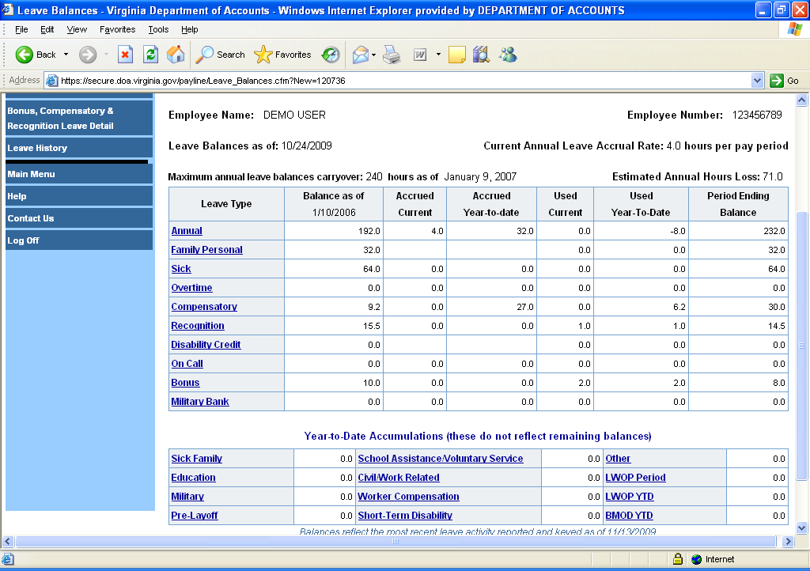

Leave History

Leave History | The Leave History page provides a listing of Leave as of Dates and agency names for which detailed information can be viewed. (The complete history listing can be viewed by using the scroll bar.) Payline users may view any ‘as of period’ by moving the mouse pointer over the desired period and click the left mouse button. This will link the user to the Reported Leave Balances page.

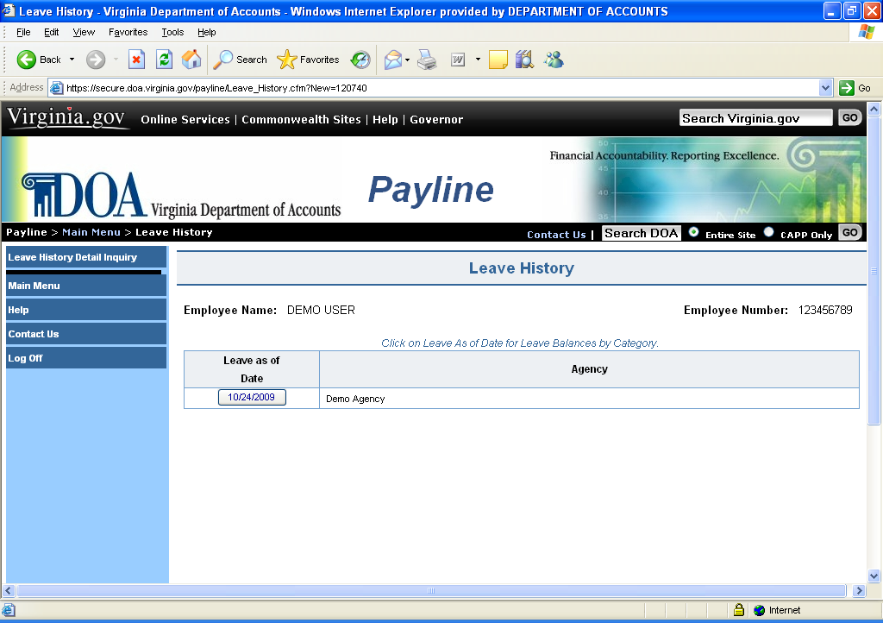

Navigation | Unique buttons found on this page are described below.

Button | Description
Leave History Detail Inquiry | Clicking on this button links the employee to a page where they may request a detailed listing of leave transactions which have been processed.
Leave As Of Date | Clicking on this button links the employee to the chosen leave period information shown by category.

Leave Balances

Leave Balances | The Leave Balances page lists leave balances by type. From this list the employee is able to view leave balances for all decremented leave types (e.g. annual, sick, etc) and year-to-date usage of accumulated leave types (e.g. military, disability, worker’s compensation, etc.). The annual leave accrual rate and maximum year-end leave balances carryover limit based on years of service is also displayed.

Disclaimer: Balances reflect the most recent leave activity reported and keyed at the close of the last leave period. The close of the leave period is the day before pay day.
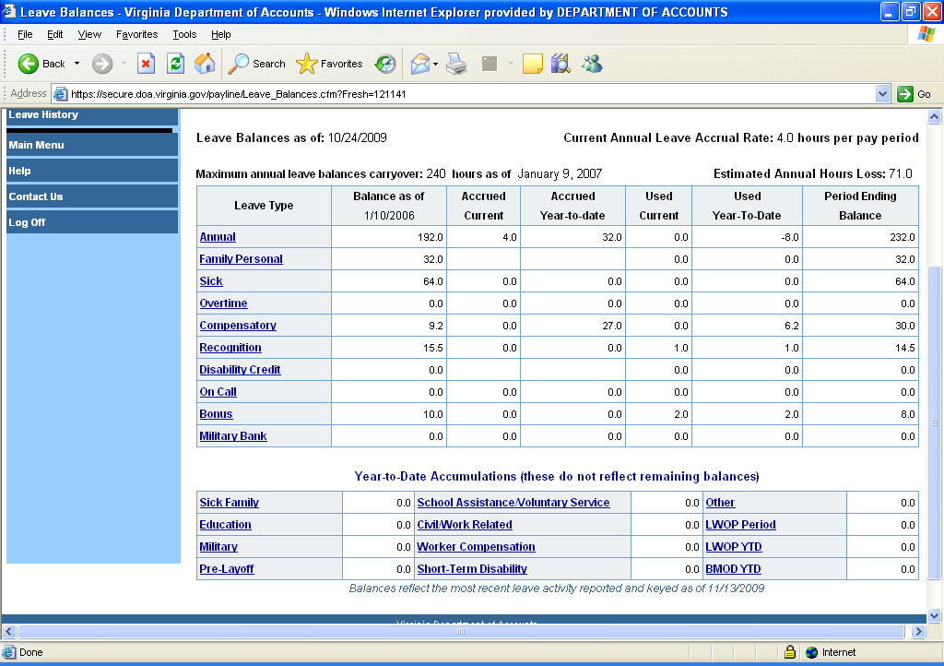

Continued on next page

Leave Balances, Continued

Navigation | Unique buttons found on this page are described below.

Button | Description
Leave Detail | Clicking on this button links the employee to a detailed listing of transactions keyed during the leave reporting period.
Bonus, Compensatory, and Recognition Leave Detail | Clicking on this button links the employee to a detailed listing of Bonus, Compensatory and Recognition Leave balances and notates leave which will be expiring.
Leave History | Clicking on this button links the employee to a listing of leave periods end dates.
TYPE | A description of each leave type can be displayed by placing the mouse pointer on the leave type/name and clicking the left-mouse button.

Bonus, Compensatory, and Recognition Leave Detail

Bonus, Compensatory, and Recognition Leave Detail | The Bonus, Compensatory, Recognition Leave Detail page provides the user the ability to view details pertaining to these leave types. The page displays the leave type, the date earned, and if the leave is expiring soon. These transactions support the current hours information found on the Leave Balance page.
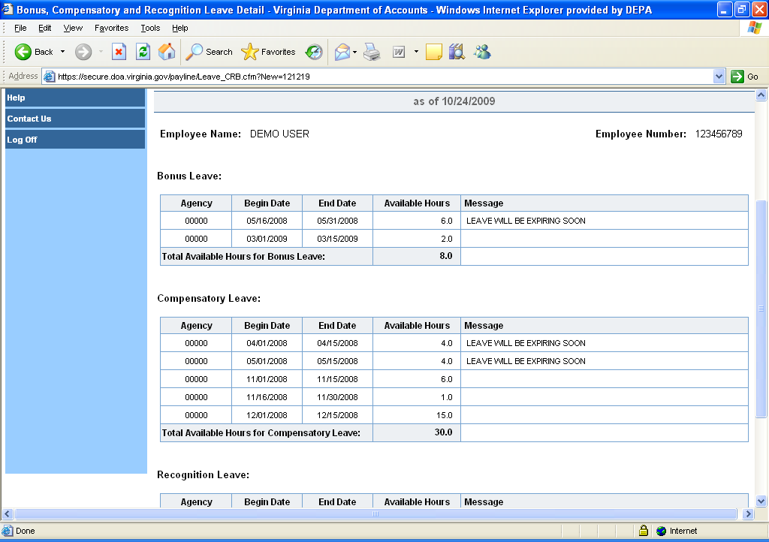

NOTE: Changes are forthcoming to change wording from a specific number of days to “expiring soon”.

Navigation | Unique buttons found on this page are described below.

Button | Description
Reported Leave Balances | Clicking on this button links the employee back to the Leave Balance page where they can view the selected ‘as of’ leave period balances.

Leave Detail

Leave Detail | The Leave Detail page provides the Payline user the ability to inquire about all detail leave transactions that were entered during a specific ‘as of’ leave period. The period selected is displayed in the heading of the page. These detail transactions support the current hours information found on the Leave Balance page.

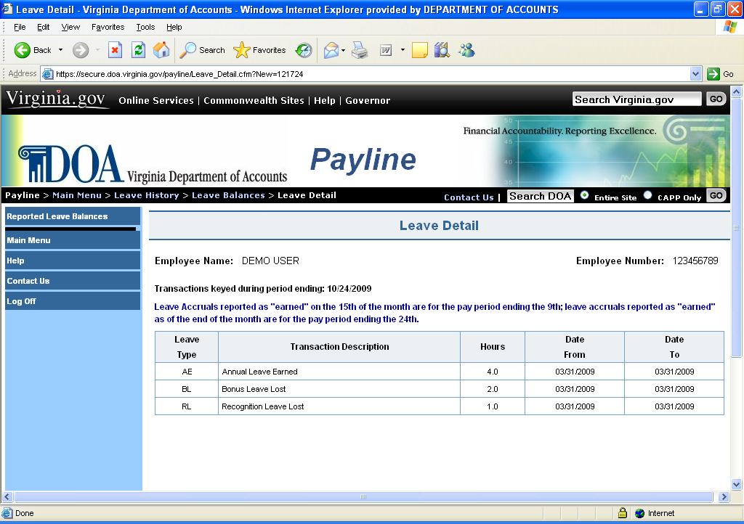

Navigation | Unique buttons found on this page are described below.

Button | Description
Reported Leave Balances | Clicking on this button links the employee back to the Leave Balance page where they can view the selected ‘as of’ leave period balances.

Leave History Detail Inquiry

Leave History Detail Inquiry | The Leave Detail Inquiry page provides the Payline user the ability to inquire about all leave types that were entered during a specific time period or specific leave types that were entered during a specified time period.  These selections are determined by checking the appropriate selection boxes provided and entering the specified leave beginning and end period dates.  When ‘All Leave Types’ is selected, all the leave types will be selected.  When ‘All Activity Types’ is selected, all leave activity types will be selected.

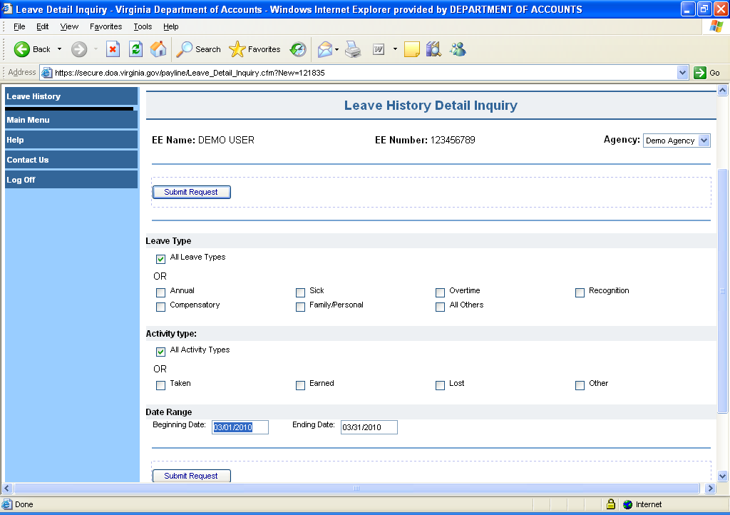

Continued on next page

Leave History Detail Inquiry, Continued

Navigation | Unique buttons found on this page are described below.

Button | Description
Submit Request | Clicking on this button links the employee to the Leave Detail Request page where the user can view the information requested on the Leave Detail Inquiry page.
Leave History | Clicking on this button returns the employee to the Leave History page.

Steps to Perform Request | Step |  | Action
 |  | 1 | Use the drop down box to select a specific agency.
 |  | 2 | Select the type of Leave desired.  - All Leave Types within a date range - shows all transactions that were keyed during the dates specified.  OR  - A specific leave type within a date range - shows the specified transaction type during the dates specified.
 |  | 3 | Select the type of Activity desired.  - All Leave Types within a date range - shows all activity transactions, within leave type, that were keyed during the dates specified.  OR  - A specific leave activity transaction type within a date range - shows the specified transaction type during the dates specified.
 |  | 4 | Date Range - complete the beginning and ending dates for the period to show all or specified leave transaction(s). See note below.
 |  | 5 | Click on the Submit Request button.
 |  | 6 | Review the Leave Inquiry Results Screen.

Displays the results of the employee's Leave History Inquiry. The screen lists in descending date order the agency number, leave type used, the number of hours keyed, and the dates the leave was taken/earned.

NOTE: The ‘Date From’ value is used to determine which transactions to reflect.

Continued on next page
Leave History Detail Inquiry, Continued

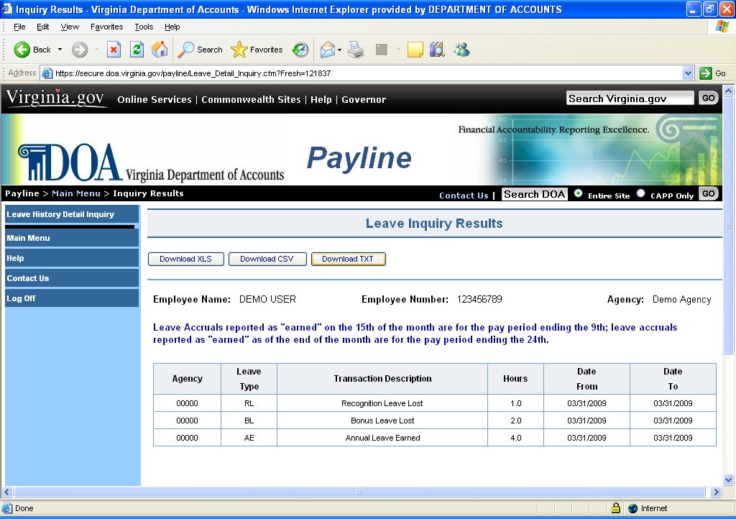

Once the results are displayed, the employee can:
- Print the results as shown on the screen.
- Download the results in an .XLS format.
- Download the results in a CSV. format.
- Download the results in a .TXT format.

By clicking on the appropriate button.

Continued on next page
Navigation | Unique buttons found on this page are described below.

Button | Description
Leave History Detail Inquiry | Clicking on this button returns the employee to the Leave History Detail Inquiry page.

Administrative Logons

Accessing the Administrative Logon Function | Masking, Reporting and Employee Number Look-Up functions are now be separated from the user’s normal Payline account. The administrative logon will have the following differences for users:  - Account will be accessed by using 99, INSTEAD OF 00, in front of the employee number (i.e. for employee number 008888888 the administrative log on ID will be 998888888).  - Passwords must be changed every ninety days and cannot match the 24 prior passwords.  - Passwords can be only changed once in a 24-hour period.  - Users will now be able to view who has requested temporary passwords, but not the actual passwords.  - Users can only use the employee number or personal id to mask an employee’s Payline record (but Emp # lookup can still be done by SSN).  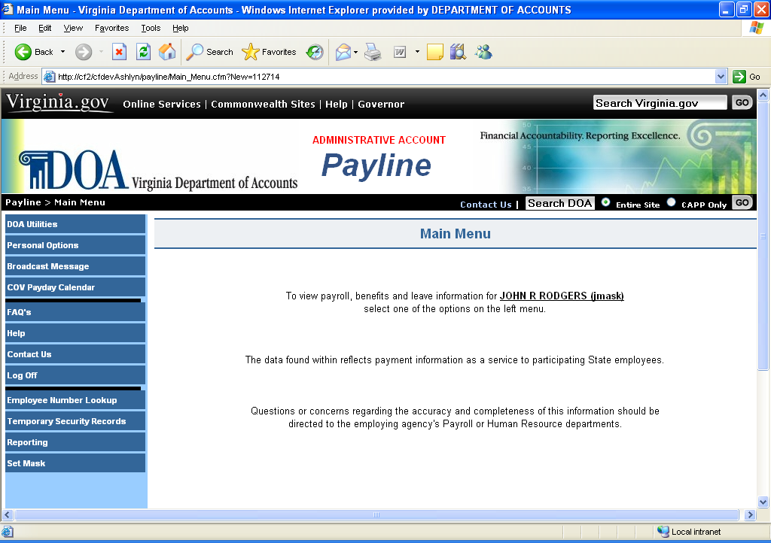  Note: Access to the administrative user’s personal data is blocked while using the Administrative Logon ID. To view personal data, the 00 (zero, zero) Logon ID must be used.

Continued on next page
Administrative Logons, Continued

Security | Access to the mask function will generally be the same as the user currently has in CIPPS Leave and/or Payroll. The security form is located at this link: http://www.doa.virginia.gov/Payroll/Forms/PaylineSecurityForm.doc.  Exceptions to parallel access must be justified on the security request form.

Masking | The mask function is the process where agency personnel can access an employee's Payline information to view and query the information as if they are the employee.

Employee Number Look-UP | The employee number look-up is the process where authorized agency personnel can enter either an employee’s Social Security Number or Employee’s Name, and query the Employee’s ID Number.

Reporting Feature | Agency personnel, who have masking, can use the statistical reporting to obtain statistical reporting of both Payline participation and earnings notice elimination.

Temporary Security Records | Agency personnel who have masking, can use the Temporary Security Record feature to view which employees have requested a temporary password.

Continued on next page

Mask Function

Masking | The mask function is the process where agency personnel can access an employee's Payline information to view and query the information as if they are the employee.

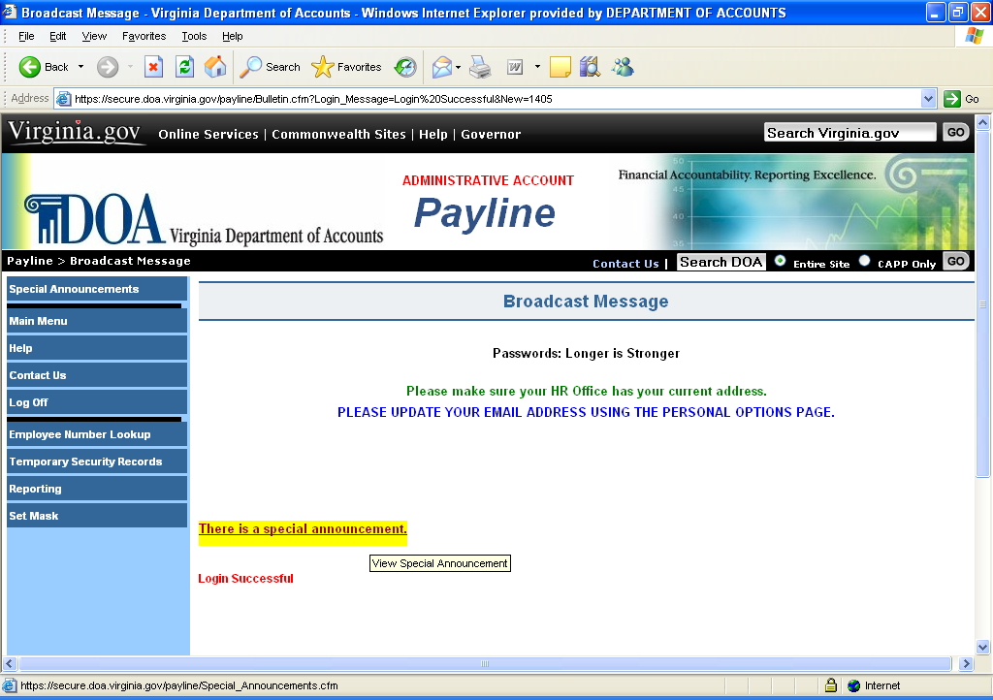

Step | Action
1 | Click on the Set Mask button.

Continued on next page
Mask Function, Continued

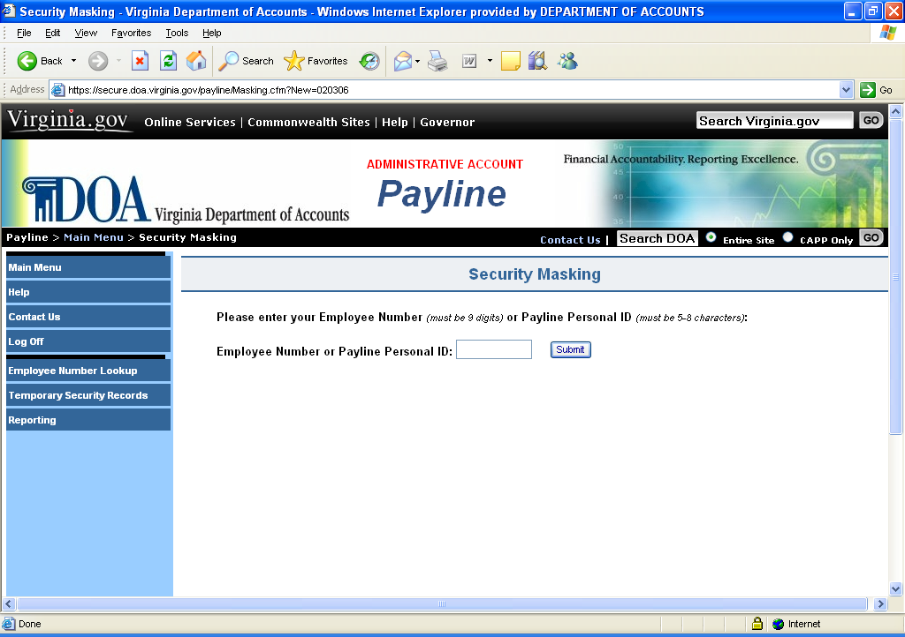

Step | Action
1 | Enter Employee Number or the Personal ID.
2 | Click on Set Mask

Continued on next page
Mask Function, Continued

The following message " Masking (Employee ID)" will be displayed:

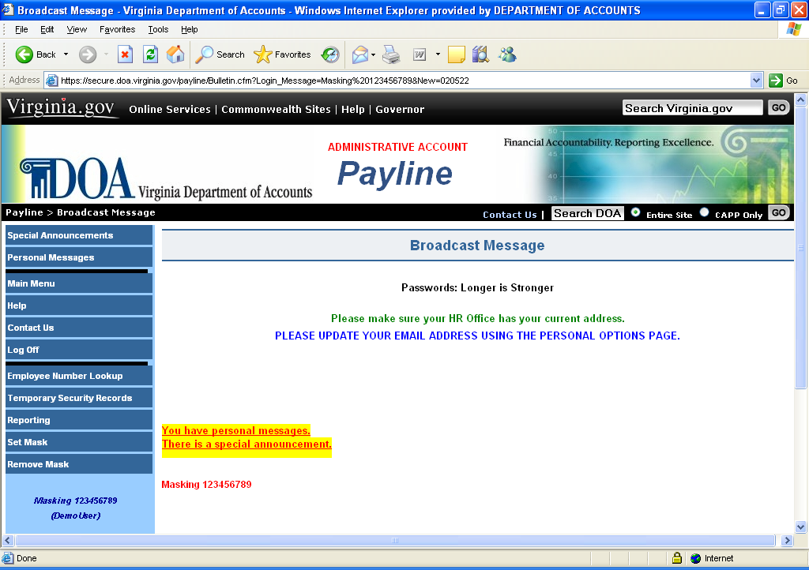

When finished masking the employee’s record, click on the Remove Mask button to mask another employee or to return to the Main Menu.:

A reminder that the user is masking the specific employee number is provided in the left hand column of each page.

And now the employee's information can be displayed as if the user is the employee.

Masking does not provide access to the employee's Personal Option Page where the individual password information is maintained.

Statistical Reporting

Reporting Feature | Payline has been enhanced for those line agency personnel who have been granted masking access to obtain statistical reporting of both Payline participation and earnings notice elimination. After logging into Payline, a button in the left-hand side entitled 'Reporting' is displayed

Step | Action
1 | Click on the Reporting button.

Earnings Notice Status by Agency | The Earnings Notice Status by Agency pages provide statistical information for those agencies for which masking access has been established. The inquiry is completed as follows:

Continued on next page
Statistical Reporting, Continued

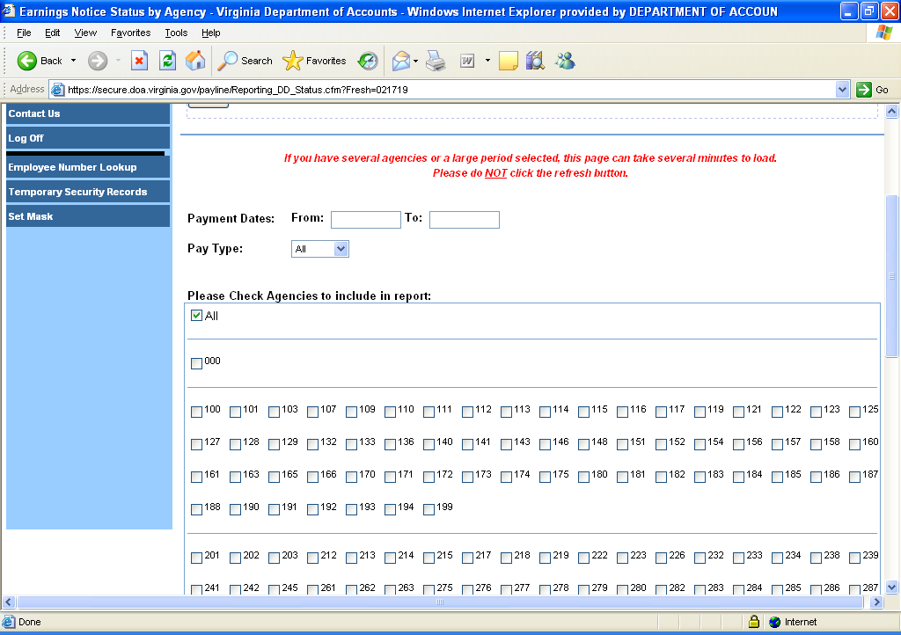

Step | Action
1 | Enter Payment Dates to include in report:  Enter the range of check dates for which statistical information is desired. (The request must use the actual check date and not the pay period dates or processing date.)
2 | Select the Pay Type from the dropdown of the employees to be reported. The options are::  - 'ALL' for all employees within agencies, or  - 'WAGE' to request wage data only, or  - 'SALARIED' to request salaried data.
3 | Check Agencies to include in report (Only the agencies for which security is granted will be displayed.):  Click on the specific agency for which the statistical information is desired. Data for multiple agencies may be requested at one time.

Continued on next page
Statistical Reporting, Continued

Earnings Notice Status by Agency (continued)

4 | Click on Accept:  Please note the message at the top of the page. "If you have several agencies or a large period selected, this page can take several minutes to load. Please do NOT click the refresh button."

Results Page | The following statistical information will be provided on the results page:  - Agency  - #Checks  - #DDs  - Total #Pmts  - Payline Participants  - Payline Participants w/DD  - Payline Participants w/DD Opt-Out  - DD Notices Printed  - DD Notices Eliminated

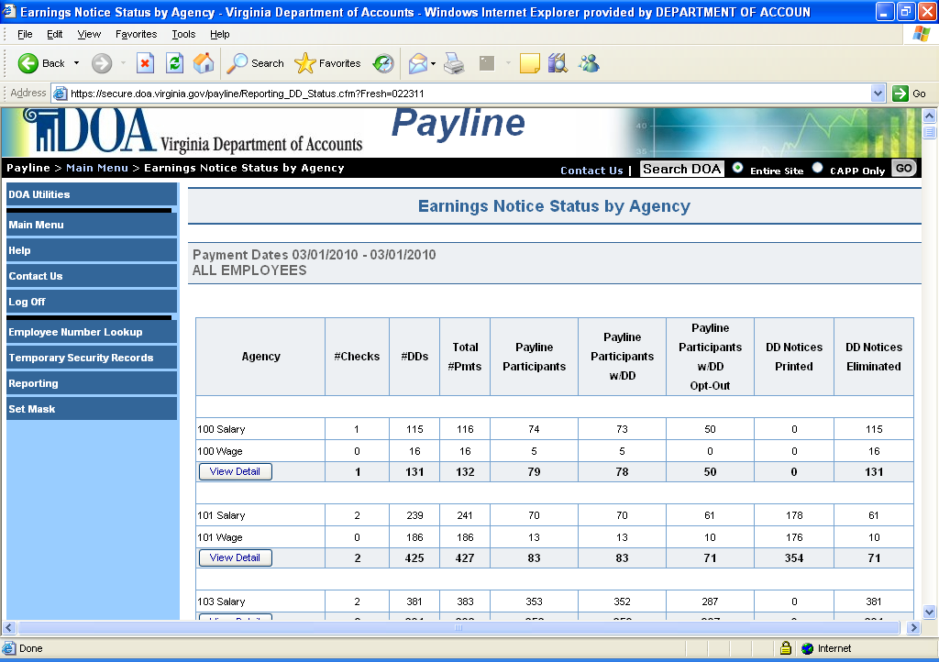
Continued on next page

Statistical Reporting, Continued

Results Page, Continued | The results page is displayed and the detailed information can be viewed by clicking on the underscored agency number for which detailed data is desired. The Earnings Notice Status by Employee page provides detailed employee information representing the check dates for which the inquiry was performed for all agencies selected. To select a particular agency, please select the underlined agency number desired.

After the criteria of the population to be displayed is selected, the following information is displayed:

- Agency
- Employee Number
- Personal ID
- Name
- Payline DD Selection
- ORG Code
- Pay Type
- Payment Status

Continued on next page

Statistical Reporting, Continued

Results Page, Continued | The results presented can vary depending on the combination of values chosen from the various drop down boxes across the top (e.g., Payment Status, Payline Participation, etc.). The Payment Status is defaulted to 'DD Notice Printed' that represents a listing of those employees who have not opted out of receiving printed earnings notices for direct deposit. The Payline Participation is defaulted to “Payline Participant". Selecting another agency or other values in the drop down boxes can modify the results presented. (Only those agencies for which masking access has been granted will display in the Agency drop down list.)
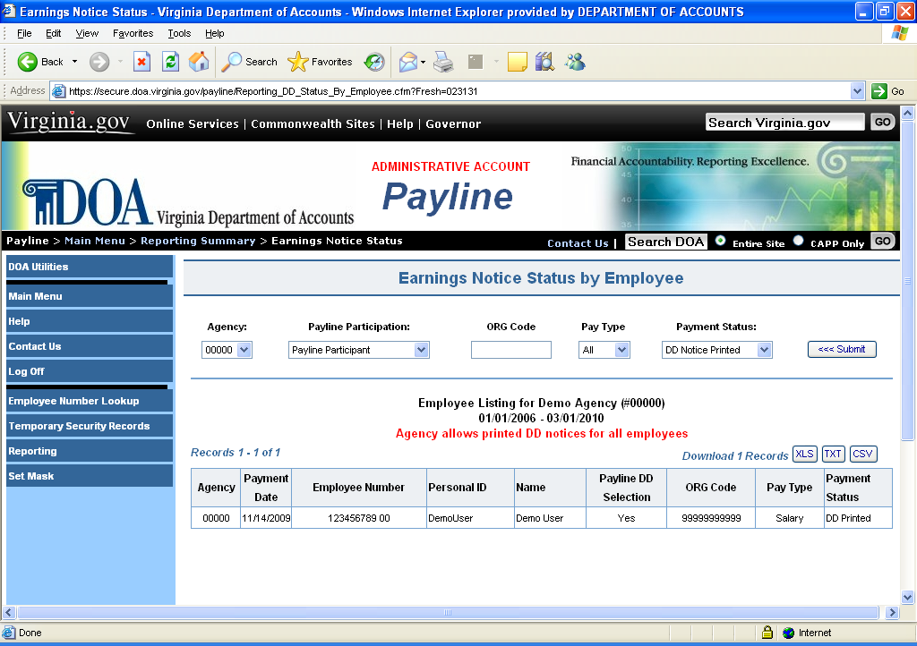

NOTE:
- Use the scroll bar to view the entire record.
- The data is displayed in ascending order of the encrypted Social Security Number (not alphabetical or unencrypted employee number order).
- Users can highlight the data and copy the information into a spreadsheet for resorting if desired.

Continued on next page
Statistical Reporting, Continued

Payment Status Options | - All - Lists all employees who received payments within the range of check dates requested.  - DD Notice Printed - Displays those individuals who participate in direct deposit and have NOT opted out of receiving a printed earnings notice.  - DD Notice Eliminated - Displays those individuals who participate in direct deposit and have OPTED OUT of receiving a printed earnings notice.  - Check Printed - Displays those individuals who do not participate in direct deposit.

Payline Participation Options | - All - Displays all employees within the group identified by the Payment Status option and check range entered on the inquiry screen.  - Payline Participant - Displays only those who have a Payline permanent security record.  - No Payline Security Record - Displays only those who have not established a Payline permanent security record.

ORG Code Options | - Blank = - Displays all employees identified by the Payment Status option and check range entered on the inquiry screen.  - Enter the 11 digit ORG Code - Displays all records for the specific ORG code chosen.

Employee Number Lookup

Employee Number Lookup Feature | Payline has been enhanced for those line agency personnel who have been granted employee number look-up access to obtain an employee number by entering either the employee’s name or Social Security Number. After logging into Payline, a button in the left-hand side entitled 'Employee Number Lookup’ is displayed

Step | Action
1 | Click on the Employee Number Lookup button.

Continued on next page
Employee Number Lookup, Continued

Employee Number Lookup Feature, Continued | 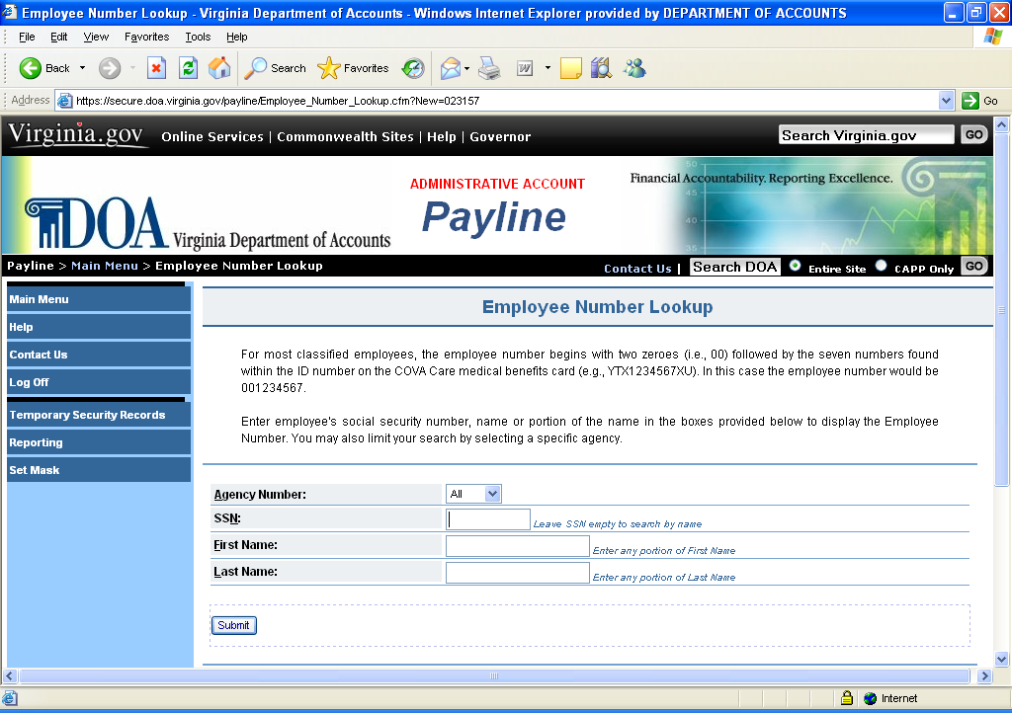

Step | Action
1 | Enter either the Employee’s Social Security Number or the Employee’s First and Last Name (can be a partial name)
2 | Click on the Submit Button.
Listed below the request fields will be the results of inquiry displaying:
- Agency Number
- Employee Number
- Employee Name

Continued on next page

Employee Number Lookup, Continued

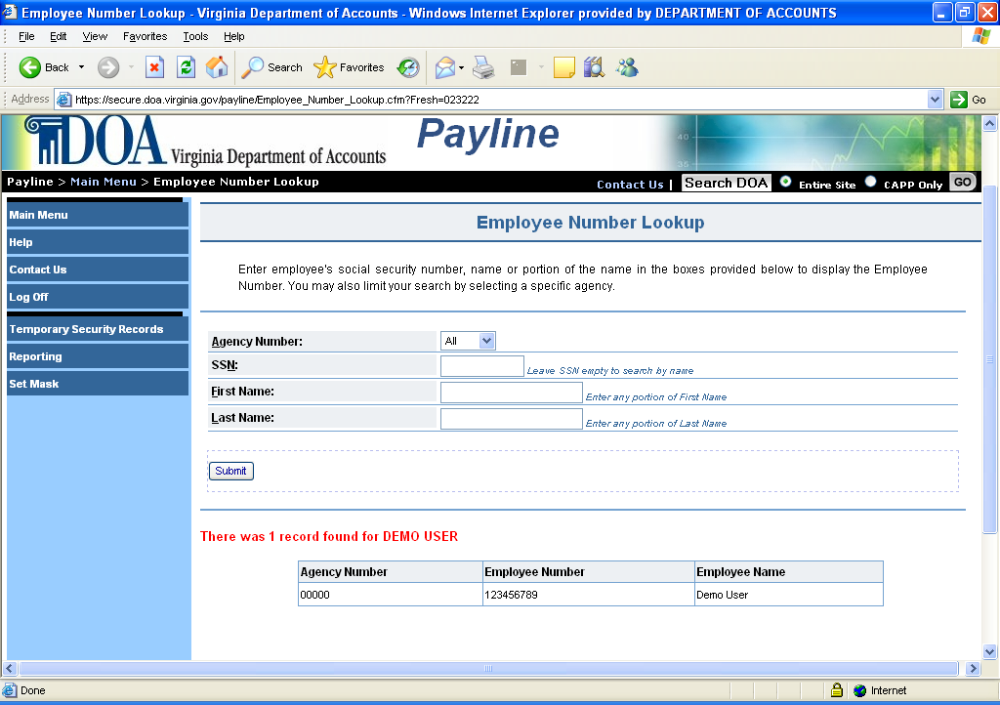

Continued on next page

Temporary Security Records

Temporary Security Records | Payline has been enhanced for those line agency personnel who have been granted masking access to view which employees have requested a temporary password through Payline.  Agency personnel can:  - Select a particular agency to view (if have security to multiple agencies).  - View by agency or particular employee ID.  - View by type of notification.  - View by check-date.

Step | Action
1 | Click on the Temporary Security Records button.

Continued on next page

Temporary Security Records, Continued
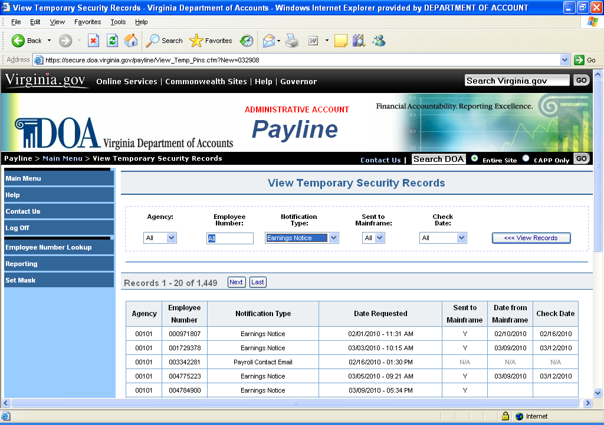

Continued on next page

Temporary Security Records, Continued

Step | Action
1 | If applicable, choose the agency you wish to view. All employees who have requested a temporary password will be listed when entering this function. OR Enter the Employee ID of the employee whose record you wish to view.
2 | To narrow the selection, you can sort the information by the following categories:  - Enter a specific Employee ID to view that one record.  - Choose a specific Notification Type,  - All  - Earnings Notice  - Email  - Choose a specific Check Date.
3 | The record displayed will show the:  - Agency Number  - Employee Number  - Notification Type  - Date the Temporary Password was requested  - Sent to Mainframe (DOA function)  - Date from Mainframe (DOA function)  - Check Date

Attachment A

CIPPS Nomenclature | Payline Earnings Nomenclature | Earnings Description
ANNUAL | Annual Lve Payout | Annual Leave Payout
ANNUAL | Annual Lve Payout | Annual Leave Balance Invol. Sep. Pay
BONUS | Bonus | Bonus Payment
CO. CAR | Company Car | Company Car
COMP LV | Comp Leave Payout | Compensatory Lve Balance Invol. Sep. Pay
COMP LV | Comp Leave Payout | Compensatory Leave Payout
DEC-PAY1 | Deceased Pay | Deceased Pay 1
DEC-PAY2 | Deceased Pay | Deceased Pay 2
HLTINCTV | Health Incntv – WW | Health Incentive Awards (Weight Watchers, etc.)
IMPLIFE | Imputed Life | Imputed Life
INV SEP | Invol Separation | Involuntary Separation
LV SHARE | Leave Share | Leave Share
LWOP-PAY | LWOP Pay | Leave Without Pay Earnings
M&R NTAX | Mov/Reloc NonTax | Moving/Relocation-Non-Taxable Earnings
M&R TXBL | Mov/Reloc Taxable | Moving/Relocation-Taxable Earnings
MIL SUPP | Military Supplement | Military Supplement
NC AWRDS | NC Awards | Value of Non-cash Awards
NONTAXBL | NonTaxable Income | Non-Taxable Income
OTIME 1 | Overtime 1 | Overtime 1 Earnings
OTIME 2 | Overtime 2 | Overtime 2 Earnings
PI BONUS | Perf Inc Bonus | Pay Plan Bonus Payment
REGULAR | Regular Pay | Regular Earnings
RPTMEALS | Reportable Meals | Reportable Meals
SEVR PAY | Severance Pay | Severance Pay
SHIFT | Shift Pay | Shift Differential Earnings
SHIFT 2 | Second Shift Pay | Shift 2 Differential Earnings
SHIFT 3 | Third Shift Pay | Shift 3 Differential Earnings
SICK LV | Sick Leave Payout | Sick Leave Balance Invol Sep. Pay
SICK LV | Sick Leave Payout | Sick Leave Payout
TAXABLE | Taxable Income | Taxable Income
TEMP PAY | Temporary Pay | Temporary Pay

Continued on next page
Attachment A, Continued

Earnings Descriptions Temporary Security Records (continued)

CIPPS Nomenclature | Payline Earnings Nomenclature | Earnings Description
VSDP BEN | Disablity Benefit | VSDP Benefit Earnings
WC SUPP | Workers Comp Supp | Worker's Compensation State Supplemental Earnings
WCSDPBEN | Workers Comp Supp | VSDP Worker's Compensation Benefit Earnings
WRK COMP | Workers Comp | Worker's Compensation

CIPPS Nomenclature | Payline Deduction Nomenclature | Deduction Description
AGY HLTH | Agy Pd Healthcare | Agency Paid Health Care Withholding
AN MATCH | Annuity Cash Mat | Annuity Cash Match
BUYBACK | VRS Ret Buyback | VRS Retirement Buy Back Withholding (Post-Tax)
CVC | C V C | Combined VA Campaign
DC MATCH | Def Comp Cash Mat | Deferred Compensation Cash Match
DCSE-SUP | DSS Child Support | Division of Child Support Withholding
DDCHKING | Direct Deposit | Direct Deposit to a Checking Account - Net Amount
DDCHKNG1 | Direct Deposit | Direct Deposit to a Checking Account - Fixed Amount
DDCHKNG2 | Direct Deposit | Direct Deposit to a Checking Account - Fixed Amount
DDSAVING | Direct Deposit | Direct Deposit to a Savings Account - Net Amount
DDSAVNG1 | Direct Deposit | Direct Deposit to a Savings Account - Fixed Amount
DDSAVNG2 | Direct Deposit | Direct Deposit to a Savings Account - Fixed Amount
DEC-NET | Deceased Pay Net | Remits 100% of net pay for deceased employee to the Estate or Beneficiary
DEF COMP | Deferred Com | Deferred Compensation Withholding
DEP CARE | Depedent Care | Dependent Care Withholding (Flex Account)
DUE AGY | Due Agency | Funds due to the agency
EEBOND1 | Series EE Bond | Series EE-BOND Withholding1
EEBOND2 | Series EE Bond | Series EE-BOND Withholding1
EEBOND3 | Series EE Bond | Series EE-BOND Withholding1
EEBOND4 | Series EE Bond | Series EE-BOND Withholding1
EMP HLTH | Health Care Prem | Employee Health Premium (Post-Tax Health Care Withholding)
EMPASOC1 | Association | Employee Association Withholding
EMPASOC2 | Association | Employee Association Withholding
EMP ORP | Mmbr Pol Appt ORP | Employee -paid portion of ORP
EMP RET | Member Retirement | Employee-paid portion of VRS
EMP TIAA | TIAA/CREF Rtirmnt | Employee-paid portion to TIAA/CREF
FED TAX | Federal Inc Tax | Federal Income Tax Withholding
FID INVS | Fidelity Inv Ret | Employer-Paid Retirement - Fidelity Investments

Continued on next page
Attachment A, Continued

Deduction DescriptionsTemporary Security Records (continued)

CIPPS Nomenclature | Payline Deduction Nomenclature | Deduction Description
GARN FEE | Garnishment Fee | Garnishment Fee
GARNISH1 | Garnishment | Garnishment, Tax Levy, Lien Withholding(s)
GARNISH2 | Garnishment | Garnishment, Tax Levy, Lien Withholding(s)
GARNISH3 | Garnishment | Garnishment, Tax Levy, Lien Withholding(s)
GARNISH4 | Garnishment | Garnishment, Tax Levy, Lien Withholding(s)
GARNISH5 | Garnishment | Garnishment, Tax Levy, Lien Withholding(s)
GARNISH6 | Garnishment | Garnishment, Tax Levy, Lien Withholding(s)
GRPINSR | Group Life Ins | Group Insurance Withholding
HI | HI Tax | Hospitalization Tax (Part of Social Security)
I-BOND1 | Series I Bond | Series I-BOND Withholding
I-BOND2 | Series I Bond | Series I-BOND Withholding
LT DISAB | Long Term Disability | Long Term Disability Withholding
MED REIM | Medical Reimbsmnt | Medical Reimbursement Withholding (Flex Account)
OASDI | OASDI Tax | Old Age Survivor Disability Insurance Tax (Part of Social Security)
OPT LIFE | Optional Grp Life | Optional Group Life Insurance Withholding
ORPAPPTE | Pol Appointee Ret | Employer-Paid Optional Retirement
PARKING | Parking | DGS Parking Withholding (Post-Tax)
PETTYCSH | Petty Cash | Petty Cash Withholding
POOL VEH | Pool Vehicle | Pool Vehicle Withholding
POST TAX | Misc Insurance | Miscellaneous Insurance Withholding (Post-Tax)
PRE TAX | Pretax Annuity | Annuity Withholding (Pre- Federal and State Tax)
PREBUYBK | Pretax Buyback | VRS Retirement Buy Back Withholding (Pre-Tax)
PRETXPRK | Pretax DGS Parkng | DGS Parking Withholding (Pre-Tax)
PRETXPRK | Pretax Parking | Non-DGS Pre-Tax Parking Withholding
PRETXTRN | Pretax Transport | Non-DGS Pre-Tax Transportation Withholding
PRM CONV | Pretax Hlth Care | Premium Conversion (Pre-Tax Health Care Withholding)
RET CRDT | Retiree Hlth Cred | Retiree Health Care Credit - VRS
RETIRMNT | Retirement | Employer-paid Retirement -VRS
SUPPORT2 | Child Support | Child Support Withholding
TIAACREF | TIAA/CREF Rtirmnt | Employer-paid Retirement -TIAACREF
TPA ADM | TPA Admin Fee | Third Party Administrator Withholding
VA TAX | State Inc Tax | State Income Tax Withholding
VEST | Vest | Virginia Educational Savings Trust
VPEP | Va Prepaid Educ | VA Pre-Paid Education Program

